Klamath Basin RiverWare  Model Testing Report

July 17, 2019

CADSWES: Mitchell Frischmeyer

# Introduction

In CADSWES’s contract, Phase 2, Task 4 “CU-CADSWES review of Klamath RiverWare Operations Model” states:

*In this task, Reclamation’s TSC will work collaboratively with CU-CADSWES to test the newly developed Klamath RiverWare Operations Model by making comparisons with the existing Iron Gate Dam calculator spreadsheet operations model. Also as part of model testing, TSC and CU-CADSWES will assist KBAO in determining if modeled operations are within the bounds of what was modeled with the Klamath Basin Planning Model (model in WRIMS platform that supported 2013 Proposed Action and Biological Opinion), assuming operating policies.*

This document summarizes the testing of the Klamath RiverWare Operations Model’s (KROM) ability to run the policy found within the Iron Gate Dam Calculator (IGD Calc). Detailed is the testing methodology, analysis of model deviations for each key variable, and discussion of KROM’s overall performance. Figures from the testing reports are shown where applicable.

# Methodology

To test the KROM’s ability to run the basin’s operations policy, the model’s outputs were compared against the IGD Calc’s outputs. The IGD Calc is currently used as the operations management tool by the Klamath Basin Area Office (KBAO), thus its outputs were used as the “true value” to which the model’s difference would be tracked. The purpose of tracking the difference is two-fold. First, it serves to locate where incorrect applications of policy may lie within the ruleset. Second, it demonstrates the KROM’s overall ability to correctly incorporate the policy found within the IGD Calc.

Due to the complex nature of the operations policy and the number of rules needed to replicate it within the KROM, one run scenario is inadequate to ensure correct application. Thus, a testing plan was developed by the members at the Center for Advanced Decision and Support for Water and Environmental Systems (CADSWES) in which 13 “operation start dates” were chosen over two sets of data. The “operations start date” is the beginning of the time period where values are predicted and computed by the model until the final timestep. For the preceding time period, all values are set directly or indirectly by observed data imported into the model. In real time, the operations start date represents the day when the operators are making decisions about the system, often the current. By choosing key operation start dates in testing, the rules are checked against sets of data that initiate a range of responses and triggers in both Spring-Summer and Fall-Winter operations.

For each run scenario, the total run period stays constant (Feb 22, 2018 to Sep 30, 2019). Only the time periods of observed data and predicted data change. To compare the KROM versus the IGD Calc, those two time periods and thus “operation start date” much be the same on each tool for the input data to match. In the IGD Calc, this is controlled from the “Dashboard” tab. In the KROM, a dedicated slot within the “Dashboard” data object is used for the same purpose. Not every “operation start date” is tested with the same method due to the changing nature of the IGD Calc. Since the IGD Calc is continually revised to incorporate updated policy, values calculated prior to the 2018 Spring-Summer period were considered invalid. Thus, to compare the older data, a copy of the IGD Calc was created with flow data from water years 2017/2018 relocated into the 2018/2019 reference cells. This allowed the 2017/2018 data to operate on the current policy. Similarly, this was mimicked in the KROM by importing the 2017/2018 data with the timesteps referenced to 2018/2019 dates.

Importing datasets and producing reports required framework inside and out of the models to execute each process. To import datasets a combination of excel sheets housing the data, DMI’s importing the data, and Scripts controlling the selection of data were developed. The excel sheets differ by the years (2017/2018, 2018/2019) and sources (KBAO, USGS, IGD Calc) of data. The DMI’s are labelled according to which sheet it imports. The scripts are separated into two, one to run the 2018/2019 datasets and the other for 2017/2018 datasets. Each script clears values set by the previous run’s DMI’s and Initialization Rules as well as imports the new dataset according to the user’s input “operation start date”. To produce reports a combination of a DMI exporting data, spreadsheets housing data, and R scripts processing data and formatting it into plots were developed. The DMI operates regardless of run type as the run period is constant. The spreadsheets differ by which model data they contain, one for the KROM and the others for the 2017/2018 and 2018/2019 versions of the IGD Calc. The R script requires the user to input which spreadsheets are referenced and the run’s “operation start date”.

With this framework in place, the model is easily setup, ran, and analyzed in a succinct process. The testing process operates as follows:

1. pick an operation start date
2. setup the script accordingly
3. run the model
4. analyze deviations identified in the output report
5. complete the necessary debugging
6. rerun and debug until issues are resolved
7. save final report
8. note sources of deviations
9. repeat process with new operation start date

# Analysis

Based off the output report’s format, this analysis covers each variable chosen for comparison and details the relative scale, tendencies, and causes of the differences observed. If influenced by similar factors, some variables are grouped. Variable figures from different runs are provided for visualizing deviations when observed vs predicted time periods vary.

## Net Accrete

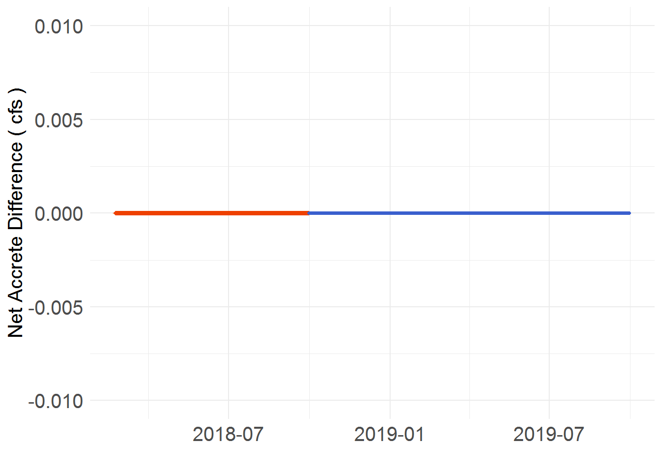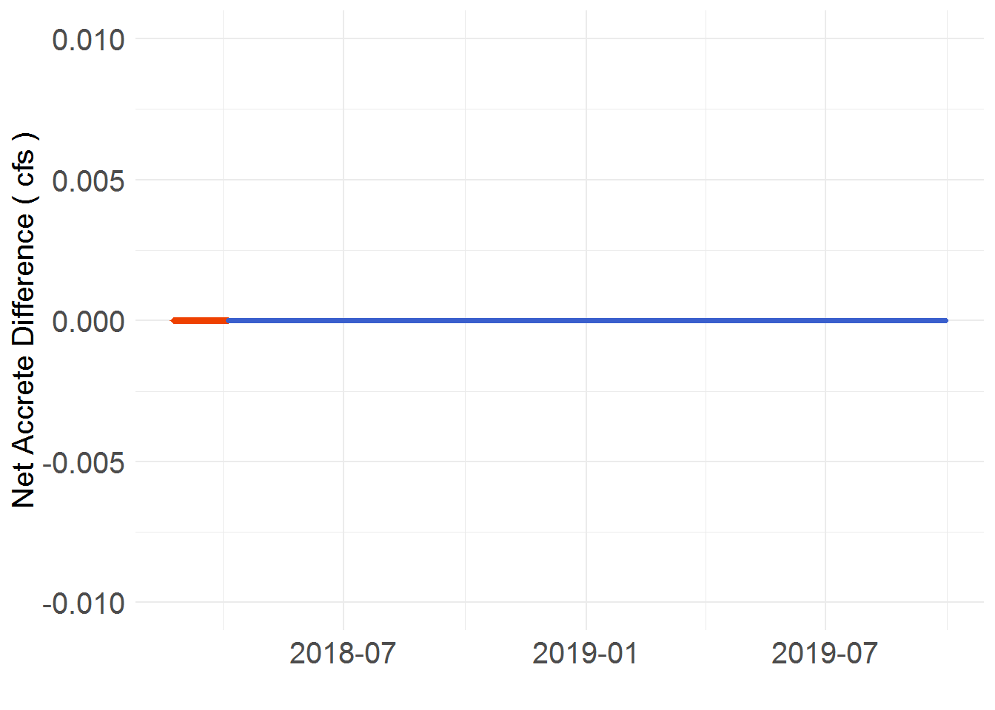

Figure 1. KROM difference for the variable Net Accrete. The plots are identified by “Operation start dates”. On the left is 1/5/2018 (Plot A) and on the right is 4/5/2018 (Plot B).

Regardless of the run’s “operation start date” or “water year” the Net Accrete showed no difference between models. There are a few reasons for this but in general it is a simple calculation with few dependencies. The Net Accrete is comprised of a sum of four main gain/loss locations, these are the following: Lost River Diversion Channel, Lake Ewauna, Keno Dam to Iron Gate Dam, and F and FF Pump. In addition, there are special considerations of usages for diversion or borrow, but these are all based off of historical values which match in both models. For the main four locations, the observed values are imported into the KROM from the IGD Calc (the intermediary excel sheet is linked to it) or they are calculated from other observed data. The location that uses a calculation is Lake Ewauna. For projected values, they all follow a similar process. To smooth the transition from observed to table referenced values, the projection is set as an average of the past six to eight days’ values. Thus, since the observed values match, so will the averaged. After this short period, all values are referenced to a table which is controlled by an exceedance value. The exceedance value is used to approximately match the current year’s condition to a column in the table containing historically averaged flows. These tables are identical in both modelling tools and therefore achieve the same result.

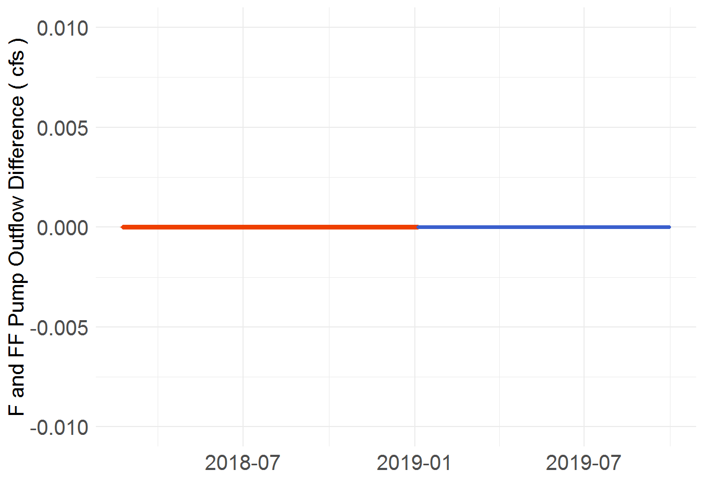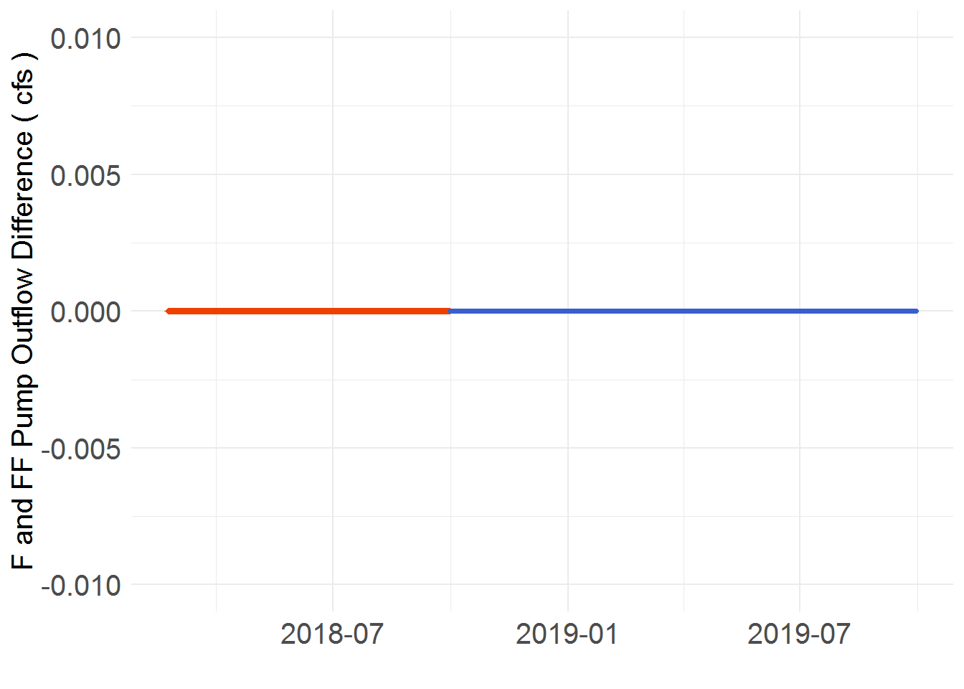

Figure 2. A primary component of the Net Accrete variable, the F and FF Pump Outflow also demonstrates no difference between the models. The plots are identified by “Operation start dates”. On the left is 1/5/2019 (Plot A) and on the right is 10/5/2017 (Plot B).

## Diversions

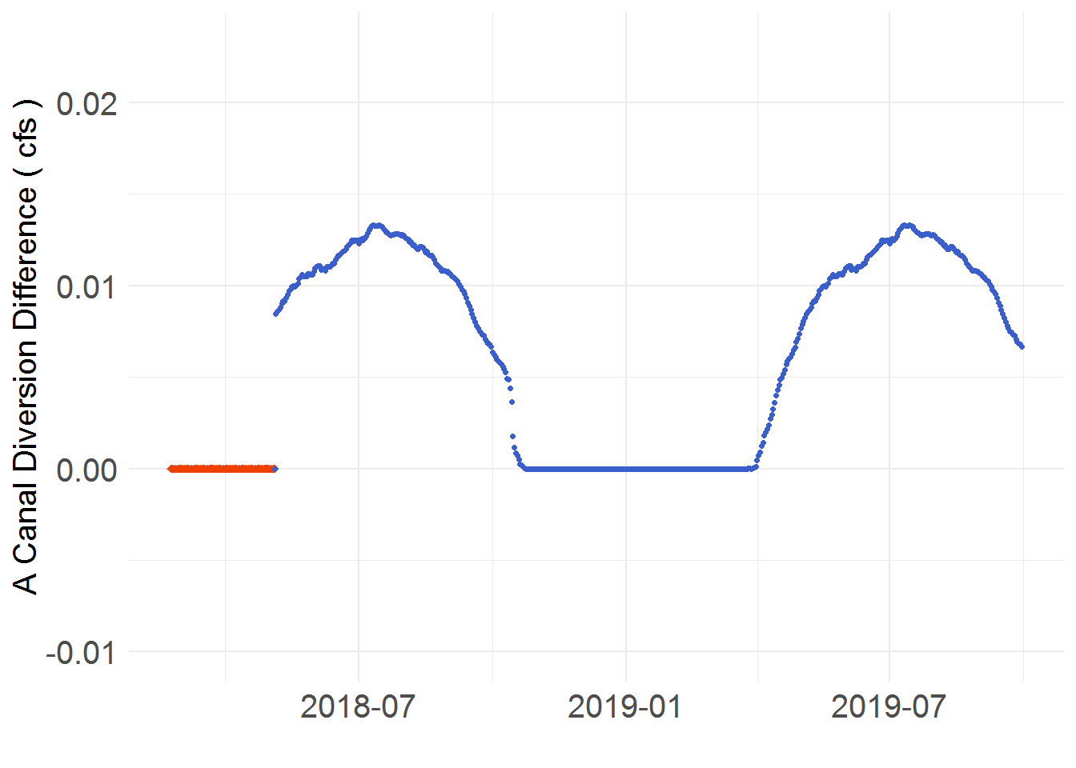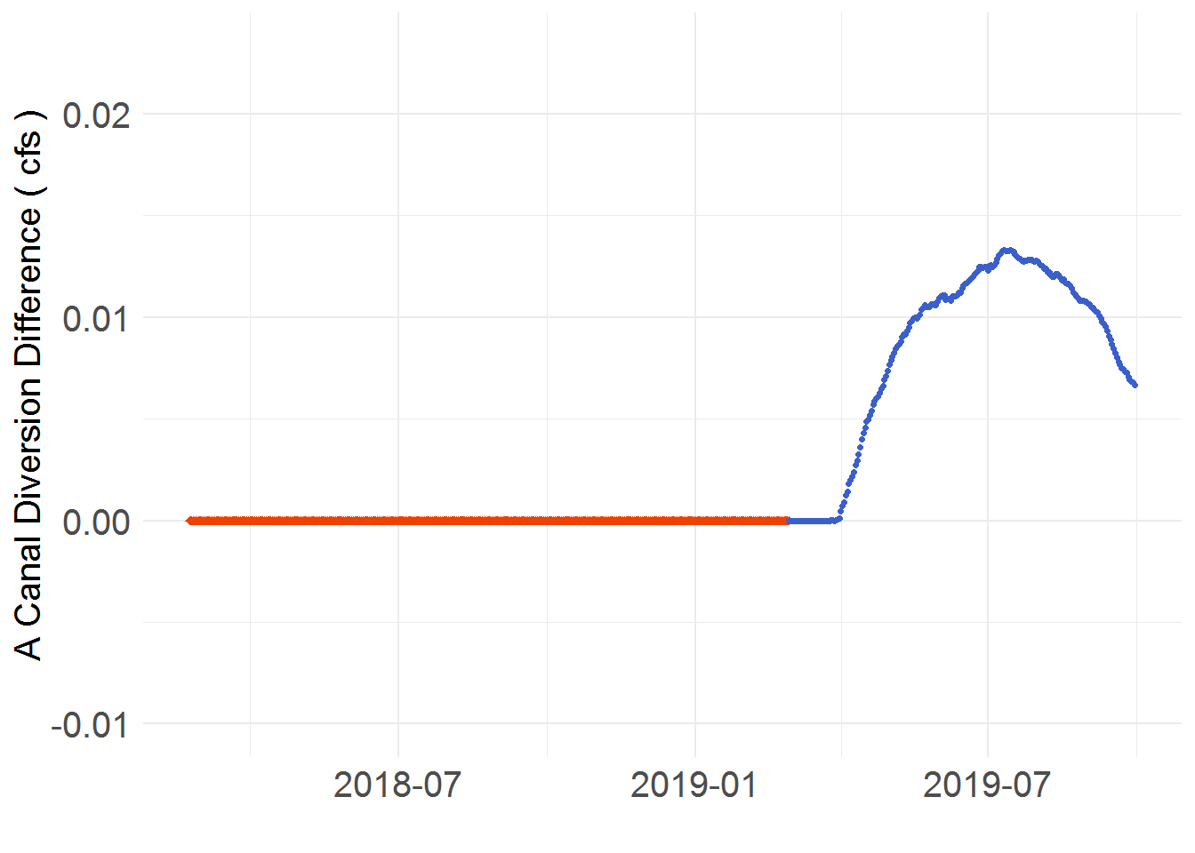

Figure 3. KROM difference for the variable A Canal Diversion. The plots are identified by “Operation start dates”. On the left is 05/01/2018 (Plot A) and on the right is 03/01/2019 (Plot B).

In each of the canals, the same pattern of differences for predicted values is noticed to be repeated yearly. The nature of this trend is a product of the method used to predict these values. For a given water year, a total volume is assigned for use by a canal. The total volume is distributed daily by a setting a percent to divert based off historical patterns. In the A canal, this process is matched in both models. The divergence shown above is a product of the different precision in which the models convert volumes to daily flows. The IGD Calc’s conversion factor is as precise as the fourth decimal whereas the KROM’s is as precise as the tenth decimal. This difference is near unnoticeable (< 0.01 cfs difference) for low volumes converted to daily flows (< 500 acre-feet). Rather, the difference becomes especially apparent when converting large volumes (> 1500 acre-feet) to daily flows due to the corresponding proportion captured by the model’s more precise conversion factor. As a reoccurring source of differences for variables in the modeling tools, this cause is denoted as “Model Conversion Difference (MCD)” for referral throughout the remainder of the report. This explains the humps seen in the figure above as a greater volume of water is assigned for diversion through the A canal in the summer than other seasons of the year.

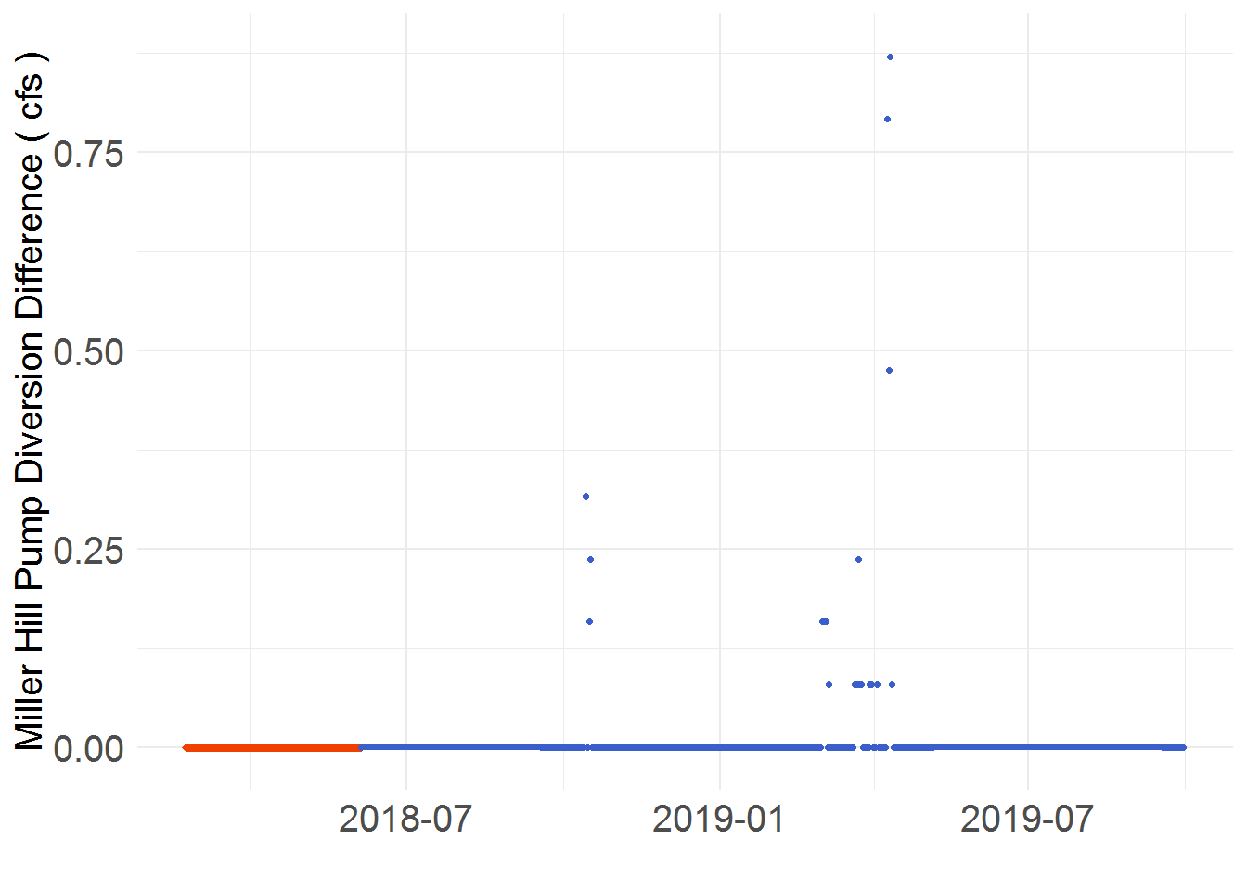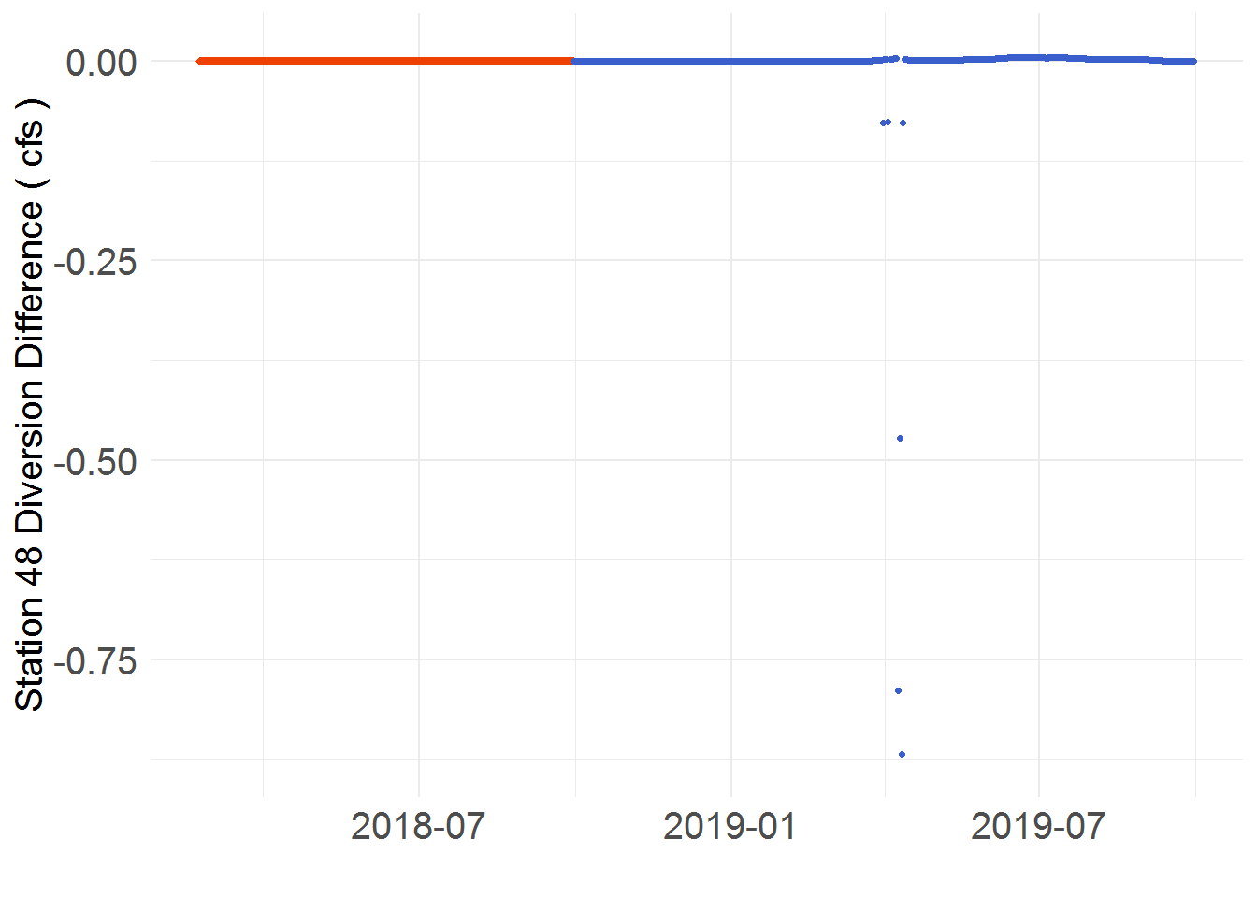

Figure 4. KROM difference for the variables Miller Hill Pump Diversion (Left) and Station 48 Diversion (Right). The plots are identified by “Operation start dates”. On the left is 06/05/2018 (Plot A) and on the right is 10/01/2018 (Plot B).

While Station 48 and Miller Hill Pump are not exempt from the MCD covered above, it is simply unoticeable since the volumes assigned remain under 400 acre-ft in addtion to other differences of greater magnitude being present. The other differences in this case are caused by the constraints of the KROM. Specifically, negative diversions cannot be routed through the channel. Periodically, the IGD Calc predicts a negative diversion request for the Miller Hill Pump. This is replicated in the KROM, but the actual diversion can only be as low as 0 cfs. Thus, a surplus of up to ~ 0.9 cfs sent to the Miller Hill Pump (diversion in KROM 0 cfs, diversion in IGD Calc -0.9 cfs) is observed. Occasionaly, a corresponding (same day) shortage of the same magnitude is observed in the Station 48. To detail why, it first must be understood that the alotted water for both channels is sent as a sum of the diversion requests. Since the diversion request can be negative but not the physical diversion, the Miller Hill Pump uses water intended for Station 48 as it precedes Station 48 in the run of the river. The corresponding water shortage is avoided when there is an excess of water entering the Lost River Diversion Channel. In this scenario, Station 48 diverts from this flow to make up for its shortage.

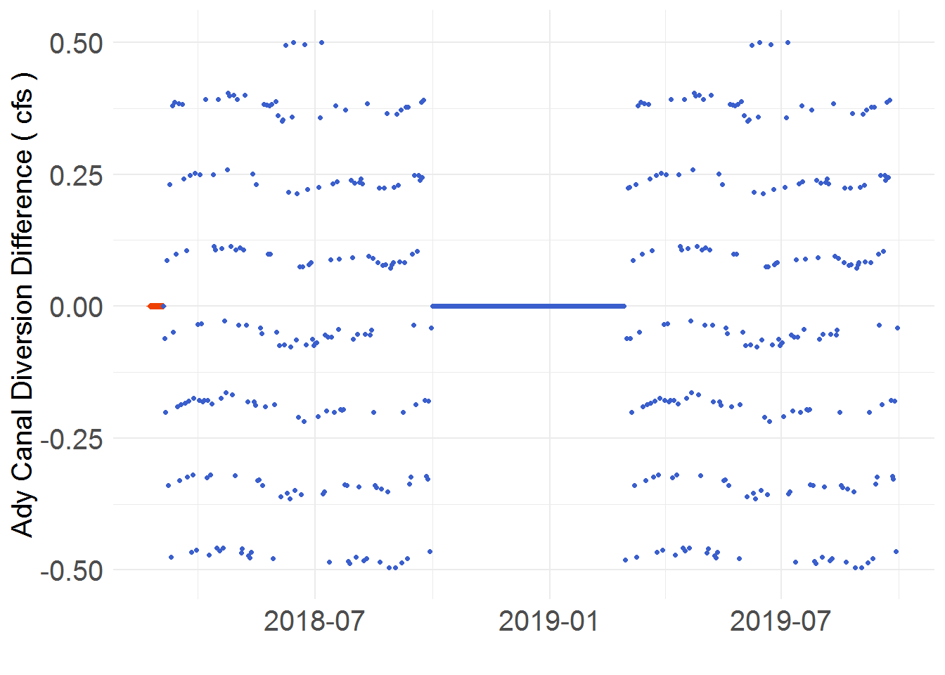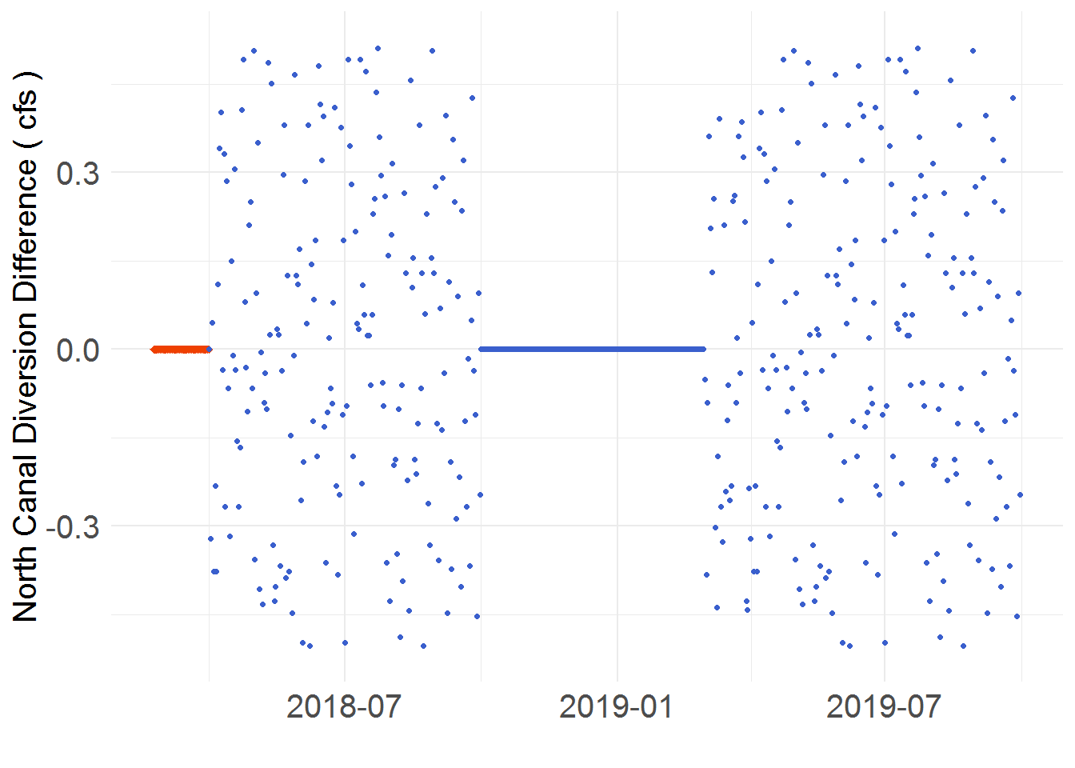Figure 5. KROM difference for the variables Miller Hill Pump Diversion (Left) and Station 48 Diversion (Right). The plots are identified by “Operation start dates”. On the left is 03/05/2018 (Plot A) and on the right is 04/05/2017 (Plot B).

Unlike the other channels, both Ady and North Canal show a scattered difference pattern throughout their diversion schedule. While the MCD plays a minor part in this occurance, the primary source is the method in which the models assign daily percentages of the yearly volume. In the IGD Calc, a rounding function is used to make the flow for diversion an integer amount. This rounding is not mimiced in the KROM. Thus, a deviation of up to 0.499 cfs is able to be observed for either channel. Larger deviations are not observed since the rounding function will always assign the nearest interger (must be < 0.5 away).

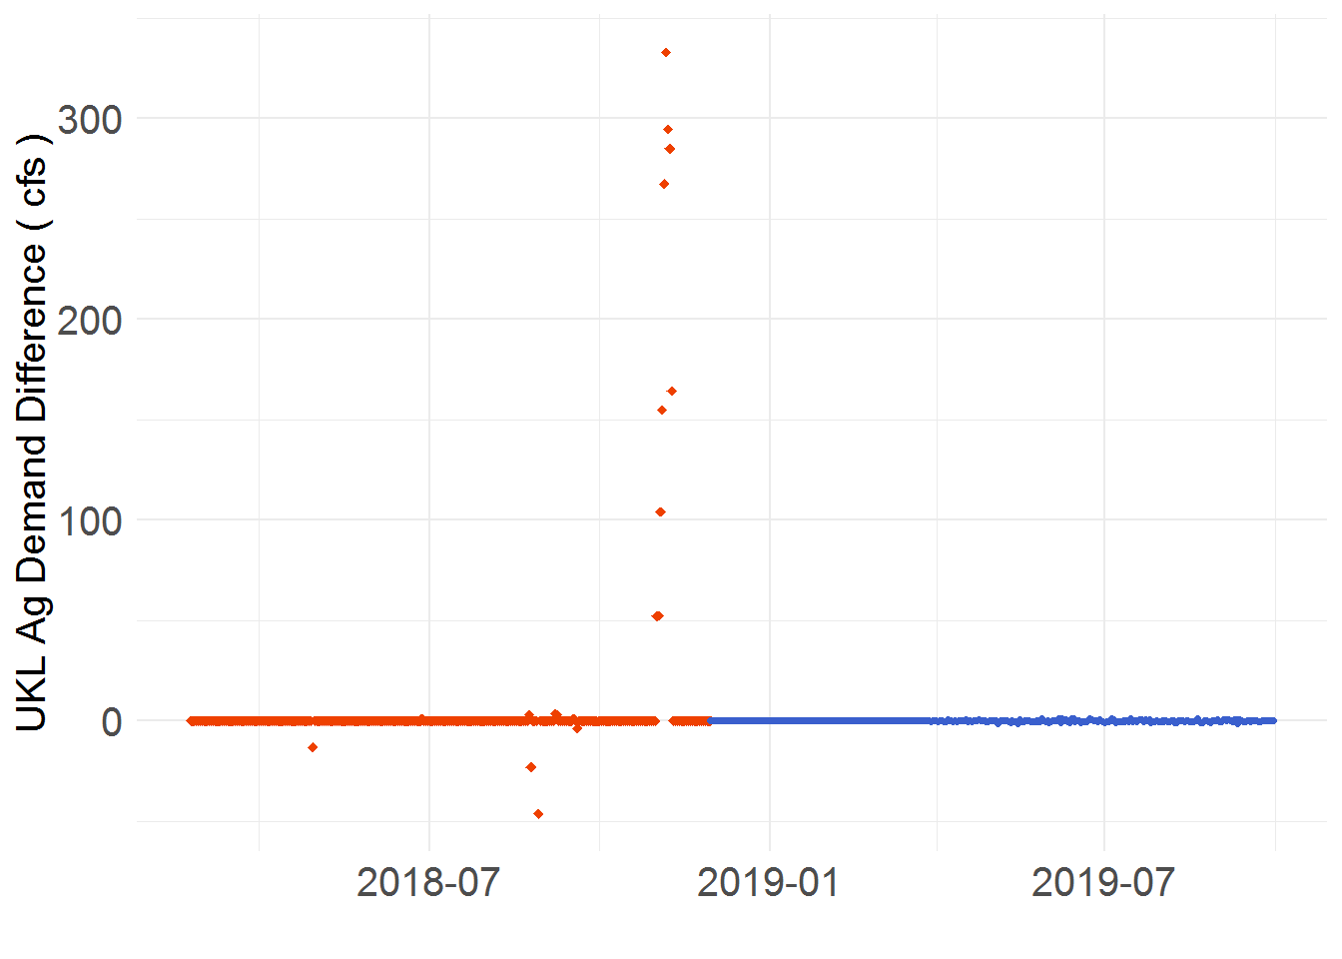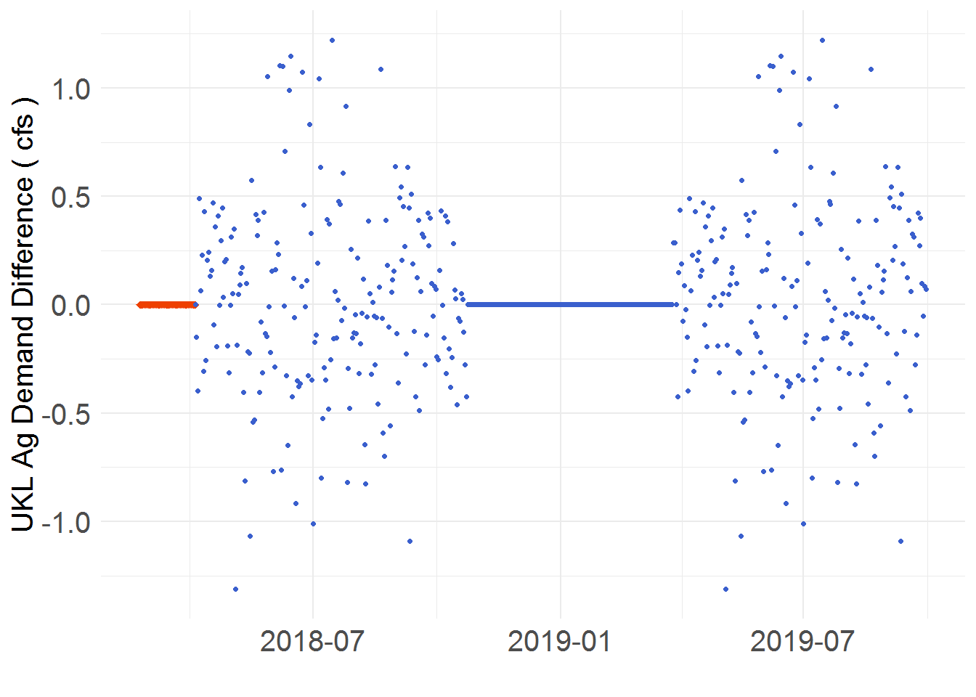

Figure 6. KROM difference for the variable UKL Ag Demand. The plots are identified by “Operation start dates”. On the left is 12/01/2018 (Plot A) and on the right is 04/05/2018 (Plot B).

The origin of model difference for the variable UKL Ag Demand is two-fold and can be seperated by which period it occurs. For the observed period, it is not entirely certain what causes the difference (Figure 6, left plot). The IGD Calc values are hard input and transferred over from another excel sheet used for recording observations. The KROM calculates these values with a rule dependent on the inputs attained from the IGD Calc. Thus, either there is a variable not accounted for in the KROM’s calculation or an error in the IGD Calc’s input for UKL Ag Demand. As for the predicted period, the difference is a sum of all the differences analyzed above (Figure 6, right plot). This explains the scattered nature (Ady and North Canal) and the extremes occuring in the summer months (A Canal, Station 48, Miller Hill Pump).

## UKL Pool Elevation

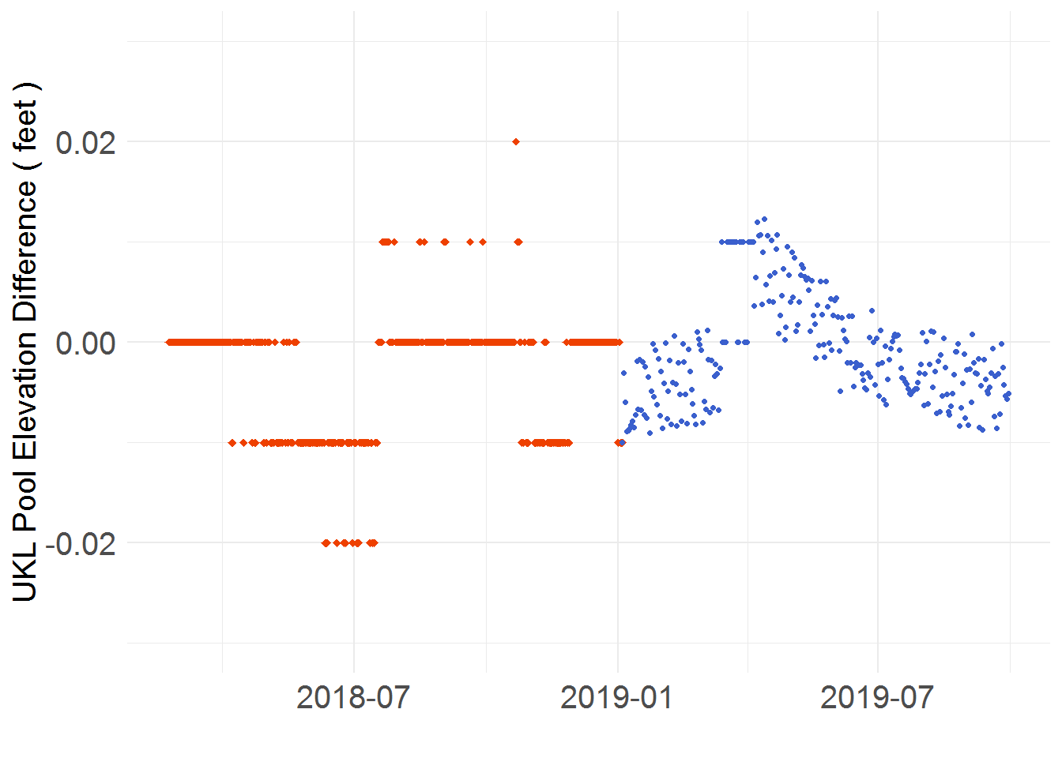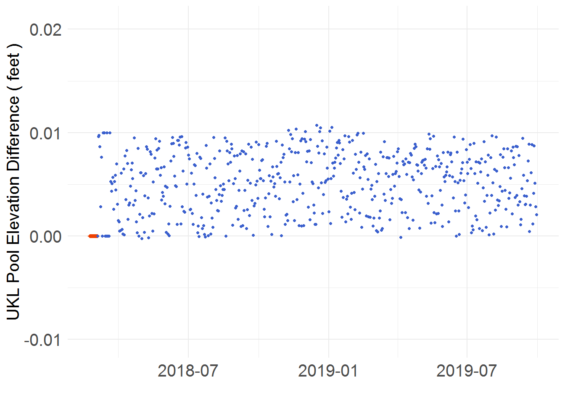

Figure 7. KROM difference for the variable UKL Pool Elevation. The plots are identified by “Operation start dates”. On the left is 01/05/2019 (Plot A) and on the right is 03/05/2017 (Plot B).

To analyze the model differences identified for UKL Pool Elevation, it is best to split the periods in two (observed and predicted). For the observed period, it was decided that an effort to obtain flow/elevation/volume data from the source rather than import it from the IGD Calc would be made. One of the variables with an identified source was UKL Pool Elevation. Thus, from the USGS website four gauges with data for this variable were collected and transferred to an input DMI. These four guage values are averaged to provide the KROM’s observed UKL Pool Elevation. This method yields a different result than the IGD Calc as it is unknown what process it uses to calculate UKL Pool Elevation (hard input). Until the IGD Calc’s method is revealed, these differences are to be accepted as suitable for the purpose of testing. For the predicted period, the scattered pattern shown in both plots of Figure 7 is a result of the MCD. Both the KROM and IGD Calc posses an identical “Elevation to Volume Table” to which a calculated volume is refenced. In the IGD Calc, a “Look Up” operation is used to pull the nearest corresponding elevation, referencing down. This is precise to the second decimal. In the KROM, an “interpolation” function is used to estimate the approximate elevation between the two nearest values. This is precise to the tenth decimal. The “Look Up” versus “Interpolation” difference is also a common cause of variable difference for the modelling tools and is denoted as “Look Up vs Interpolation (LUvI)” for referral throughout the remainder of the report. Sometimes sudden shifts in elevation will occur as in Plot A of Figure 7. This example is a result of flood control operations setting elevation and outflows. Other shifts may be explained by elevation dependent fill rates being triggered early. The general scattered pattern of the plot is attributed to slight precision differences in variables used to set the outflow or even the outflow itself (see MCD). The KROM UKL Pool Elevation typically stays within a hundreth above the IGD Calc’s elevation. The KROM maintains this accuracy since outflows are dependent on elevation and are designed to keep elevation near an idealized seasonal curve. Thus, once the elevation diverges too far, the outflow automatically adjusts to shift elevation towards the curve value. The KROM’s elevation tends to be above as the IGD Calc references the lower elevation with its “Look Up” function.

## Flood Release

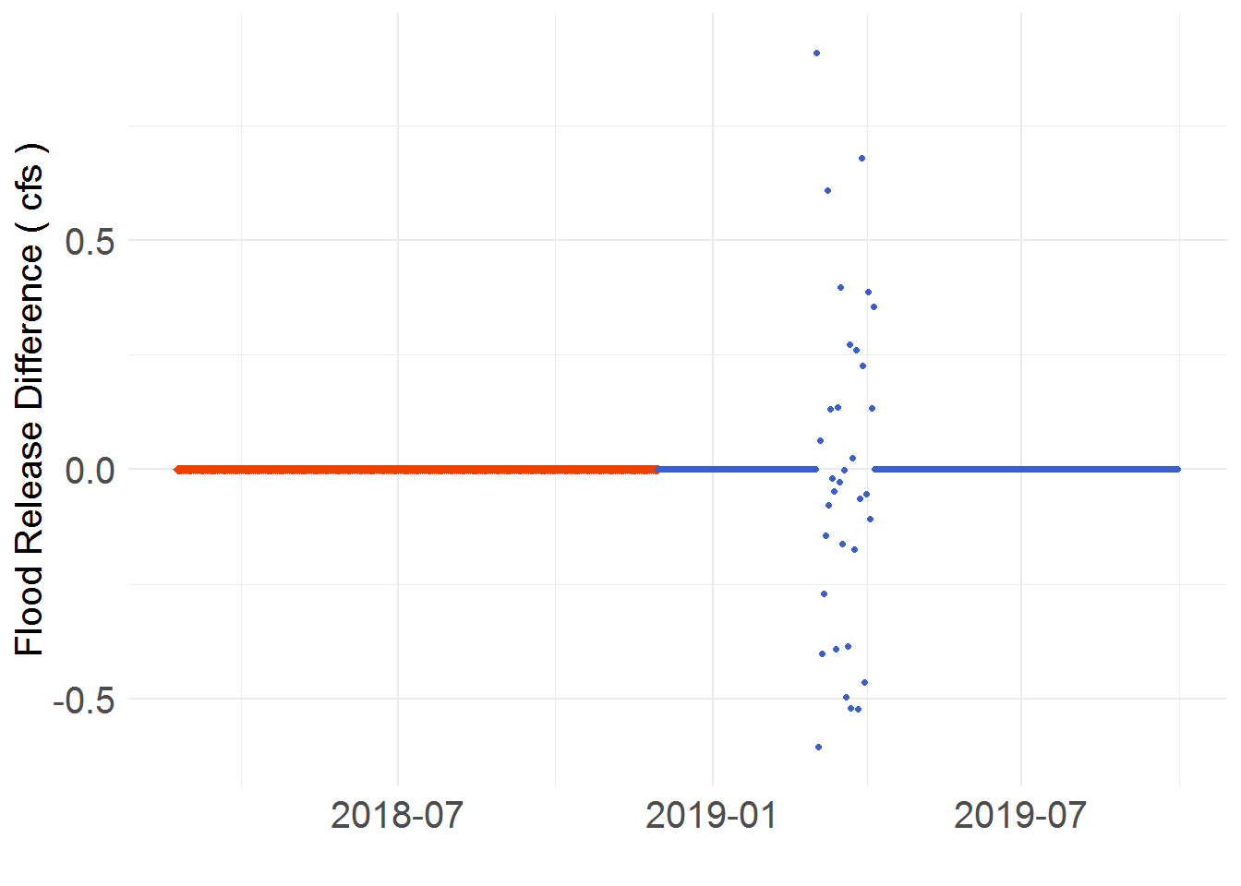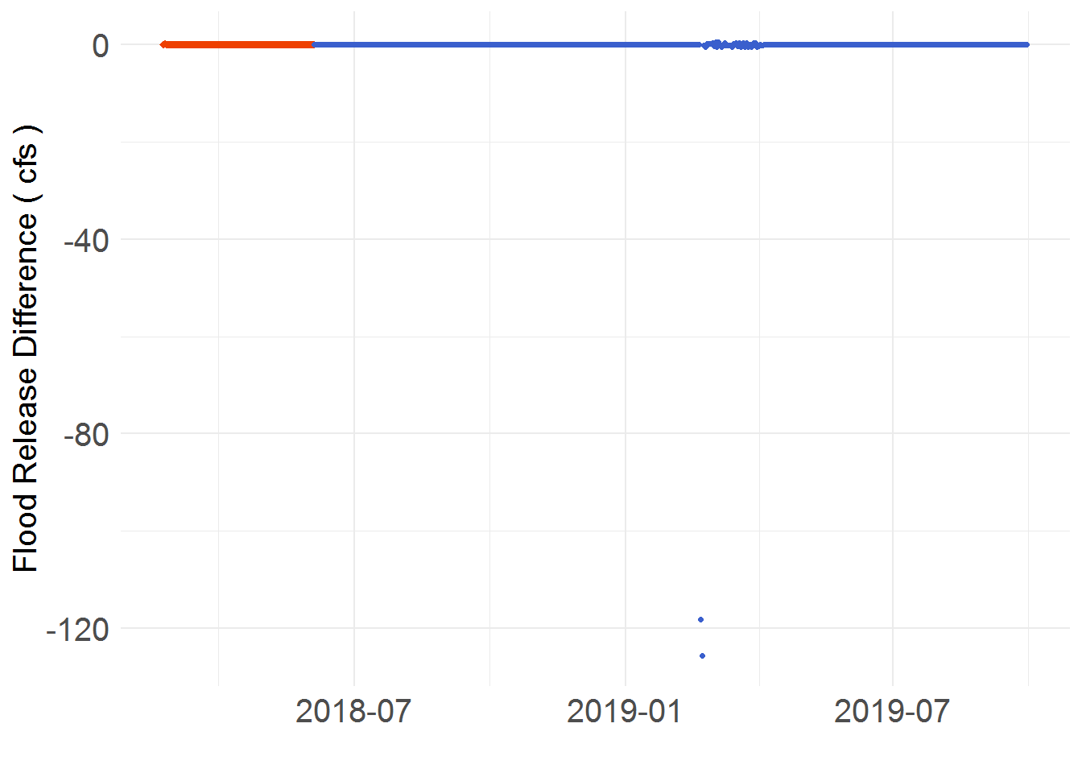

Figure 8. KROM difference for the variable Flood Release. The plots are identified by “Operation start dates”. On the left is 12/01/2018 (Plot A) and on the right is 06/05/2017 (Plot B).

In the scenario where flood control operations are iniated, the deviation between the KROM and IGD Calc will depend on one factor, the storage volume in Upper Klamath Lake (UKL). When flood control operations are initated, the UKL is forced to an elevation that averts the risk of overtopping by releasing a calculated volume of water. A release which is dependent on the mass balance of:

Inflows (@”t”) + Storage (@”t-1”) – Storage (@”t”) – Diversions(@”t”) = Release(@”t”) 🡪 vol to flow

The @”t” symbod denote the occurance of a one day period. Thus @“t” is the current day and @“t-1” is the previous. The values above can either be in average flow for the day or the volume of flow delivered that day. In this context, volumes are used as this is the units used in both modelling tools.

Of the variables above, the inflows and new storages are both referenced from tables which are identical in the models. In addition, the diversion (A Canal) is known to have a slight difference (see the MCD and A Canal Diversion). Thus, leaving the primary source of difference as the previous day’s storage (see Elevelation section). Figure 8 demonstrates the extent that the flood release is affected. On Plot A, the previous day’s volumes are near identical and the release for flooding never excedes a difference above 1 cfs. Differences noticed in this run are caused by A Canal Diversion and UKL Inflow (product of the MCD). On Plot B, the previous day’s storage differed by approximately 700 acre-feet and releases are off up to ~ 350 cfs for two days to reach an equivalent flood elevation level. If the difference was made up in one day, the release would have resulted in flooding downstream. Logic in the flood control operations prevents that to a certain extent.

## EWA Used and Remain

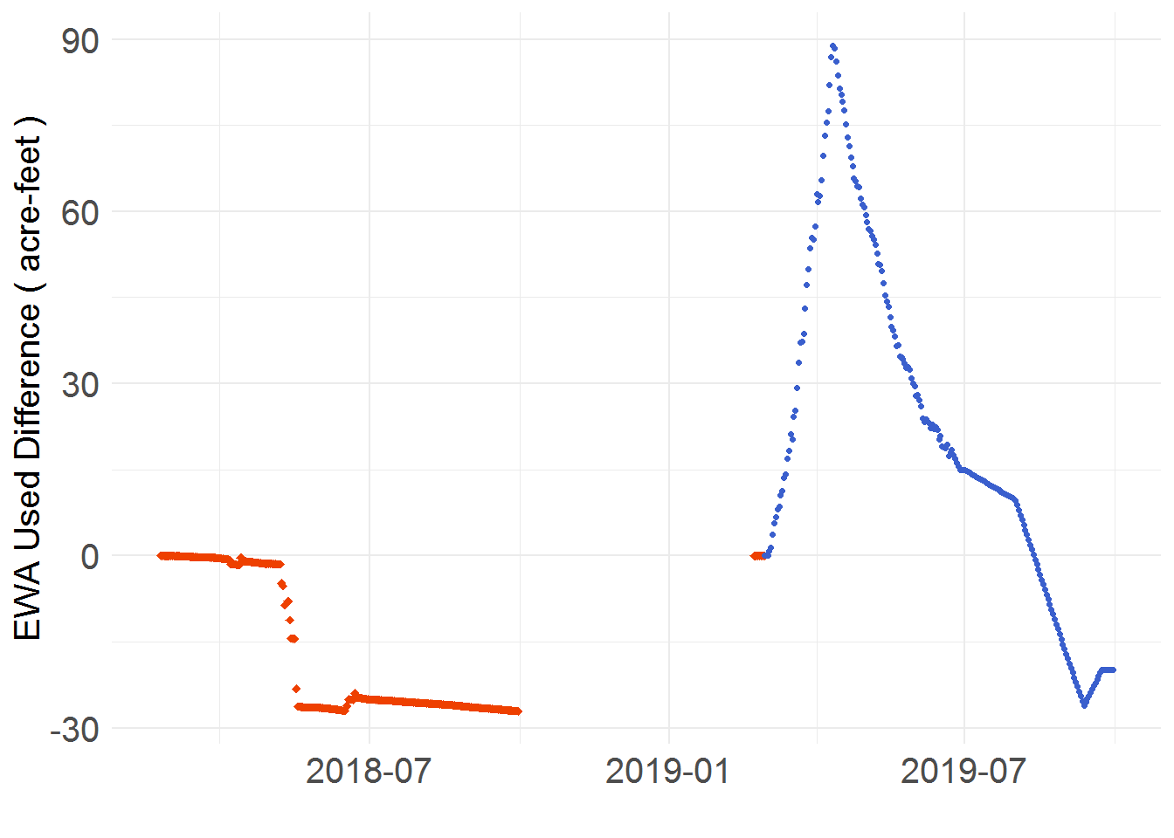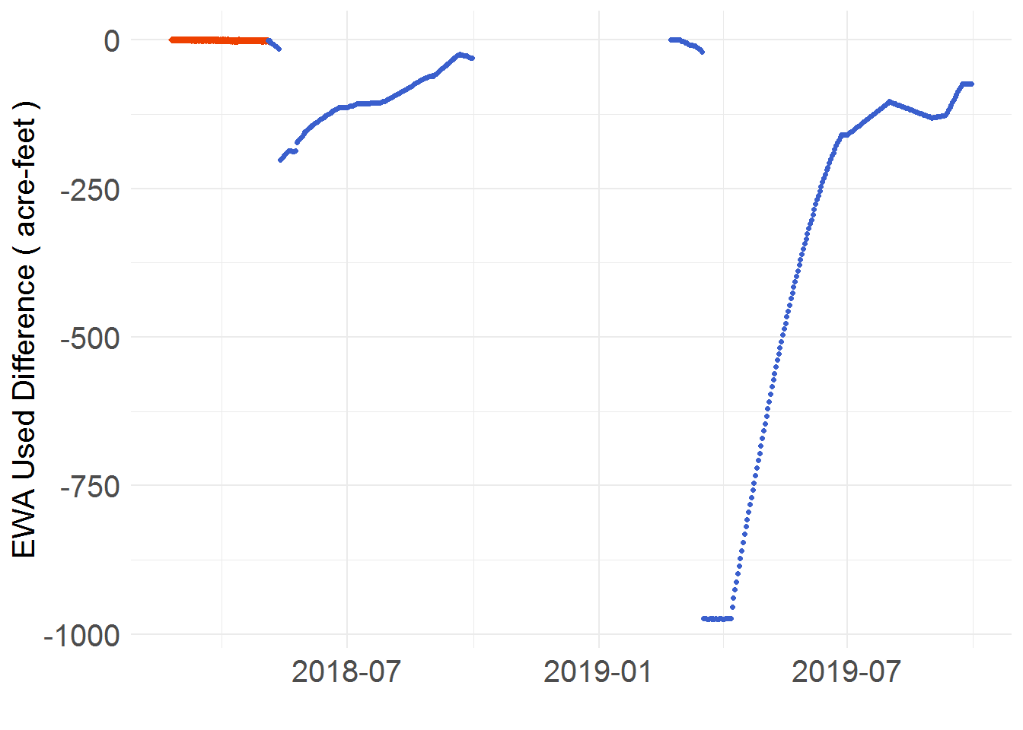

Figure 9. KROM difference for the variable EWA Used. The plots are identified by “Operation start dates”. On the left is 03/01/2019 (Plot A) and on the right is 05/05/2018 (Plot B).

The variable EWA Used is a sum of all the releases from UKL for environmental purposes. Thus, releases for IGD, flooding, minimum river flows, and ramping all contribute to this volume. Analyzing Plot A of Figure 9, the KROM’s value tends to keep near the IGD Calc’s. Near is a relative term as the EWA Used volume grows to upwards of 500,000 acre-feet, making a difference of 50 acre-feet insignificant. The Plot A run keeps close for a couple of reasons. First, no flood operations occur during this run. Second, the Spring Fill Rate is active on the same timesteps as the IGD Calc. Therefore, the influence driving variation between the models is the Spring Fill Rate’s value. This value is calculated as ratio of the current day’s elevation over the target elevation when a max elevation hasn’t been established for six days or the date falls after June 1st. Since its established that elevation varies (see LUvI) in both the observed and predicted periods, this ratio expectedly differs and influences an over or under release from UKL. As a sum of these releases, the EWA Used volume differs as well. In the Plot B run, both flooding and late deactivation of the Spring Fill Rate occur. The difference in 2018 is caused by the KROM’s Spring Fill Rate activating longer than the IGD Calc’s. This reduces the release from UKL for IGD by ~ 80 cfs and causes a corresponding ~ 160 acre-ft deficit in EWA Used. In 2019, the deficit is caused by a difference in flood release between the models. Since the KROM is at a closer elevation to the desired level when flood operations begin, it releases less water than the IGD Calc. This ~ 60 cfs reduction in flow leads to a ~120 acre-ft defecit in the EWA Used volume. Additionally, the KROM’s EWA Used volume appears to exhibit a trend of drifting back towards the IGD Calc’s EWA Used volume. This occurs as the EWA Used is designed to sum to a total volume alotted for the year. The total volume being the Environmental Water Account or EWA. Thus, the rate will adjust to empty the EWA over the Spring-Summer season which causes the models’ EWA Used volume to converge.

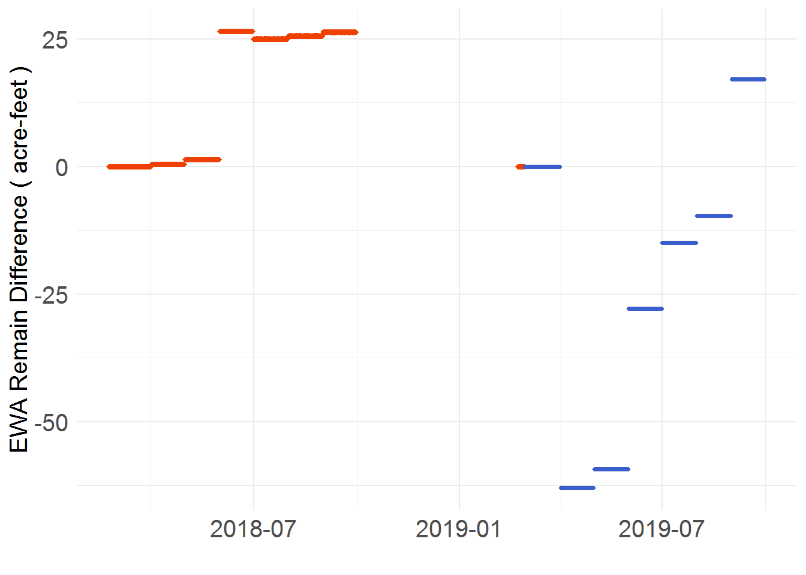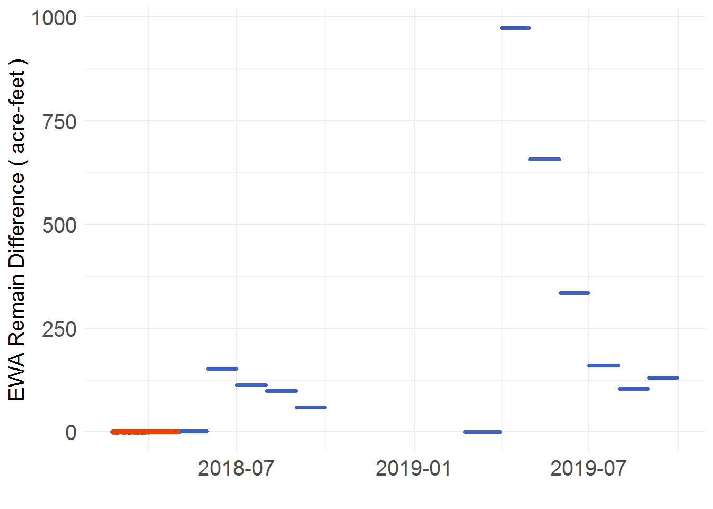

Figure 10. KROM difference for the variable EWA Remain. The plots are identified by “Operation start dates”. On the left is 03/01/2019 (Plot A) and on the right is 05/05/2018 (Plot B).

The EWA Remain is the difference of two variables, the EWA and EWA Used, and is calculated at the beginning of each Spring-Summer month. Thus, if the EWA Used volume is off at the beginning of a month, so is the EWA Remain’s. A differing EWA Remain does not affect other model outputs until July. From July til the end of the summer, the UKL for IGD is taken as the EWA Remain for July thru September divided over the days in the month. This value is referenced from a table using the total EWA Remain as the lookup. Thus, any deviation in EWA Remain is reflected in the UKL for IGD release.

## Link Fall Winter Target

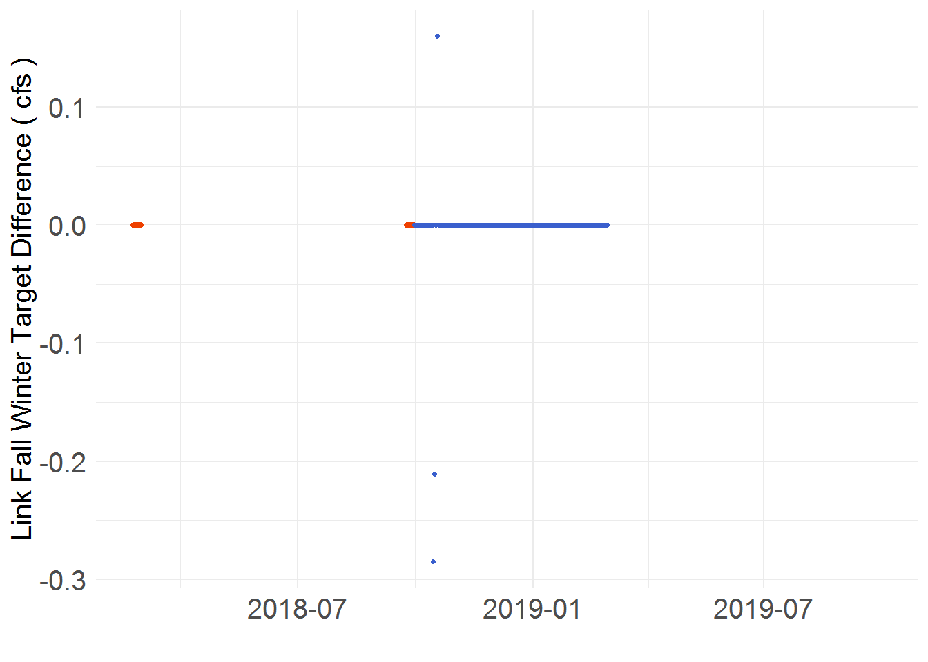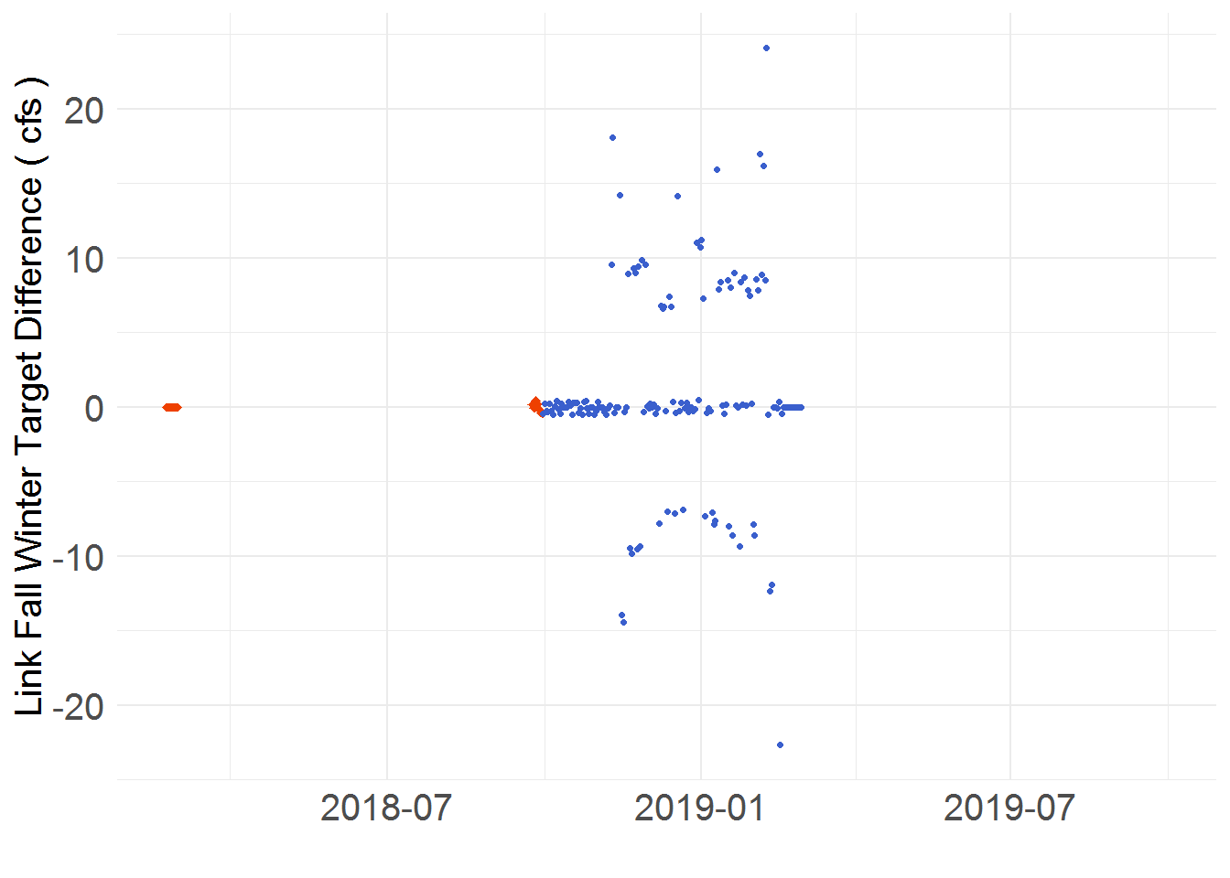

Figure 11. KROM difference for the variable Link Fall Winter Target. The plots are identified by “Operation start dates”. On the left is 10/01/2018 (Plot A) and on the right is 10/01/2017 (Plot B).

In both datasets (2017/2018 and 2018/2019), scarcely any differences occur during the observed period. Only in the 2018/2019 dataset are a few caused by varying elevations (see Elevation section). However, for the predicted period, unique trends arise in each set. In the 2017/2018 set, differences of 6 to 20 cfs commonly occur. Whereas, little to no differences appear throughout the 2018/2019 set. Even when differences do occur in the 2018/2019 set, they are marginal, equating to 0.1 thru 0.5 cfs. These minor differences are correlated to the variable Link Release FW setting the target flow. A difference whose source is traced back to the Williamson Inflow. Differing by a thousandth of a decimal between models, it propagates when multiplied by the Williamson Proportion Factor. A factor that sets the Link Release FW and sequentially the Link Fall Winter Target.

There are no differences when the target release is set by the variable Link Release for IGD Min, the target flow’s other dependency. This is due to Link Release for IGD Min being set by the Net Accrete and a table referenced minimum flow. As covered earlier, the Net Accrete exhibits no difference and the table reference won’t either as long as it is identical in both models. Just as the 2018/2019 dataset’s difference is traced back to the Link Release FW, so can the 2017/2018 dataset’s difference. Except, in this set the Williamson River Inflow is not the source. Rather, it is the UKL Pool Elevation. The UKL Pool Elevation is used to set the fill rates which determine the Accretion Adj Factor. The Accretion Adj Factor is one of the dependencies of the Link Release FW and transitively the Link Fall Winter Target. It has been established that the UKL Pool Elevation deviation is highly variable (LUvI). Thus, this variability propagates through the chain of calculations used to set the target flow and skews models’ differences up to 20 cfs.

## UKL for IGD, for River, and Outflow

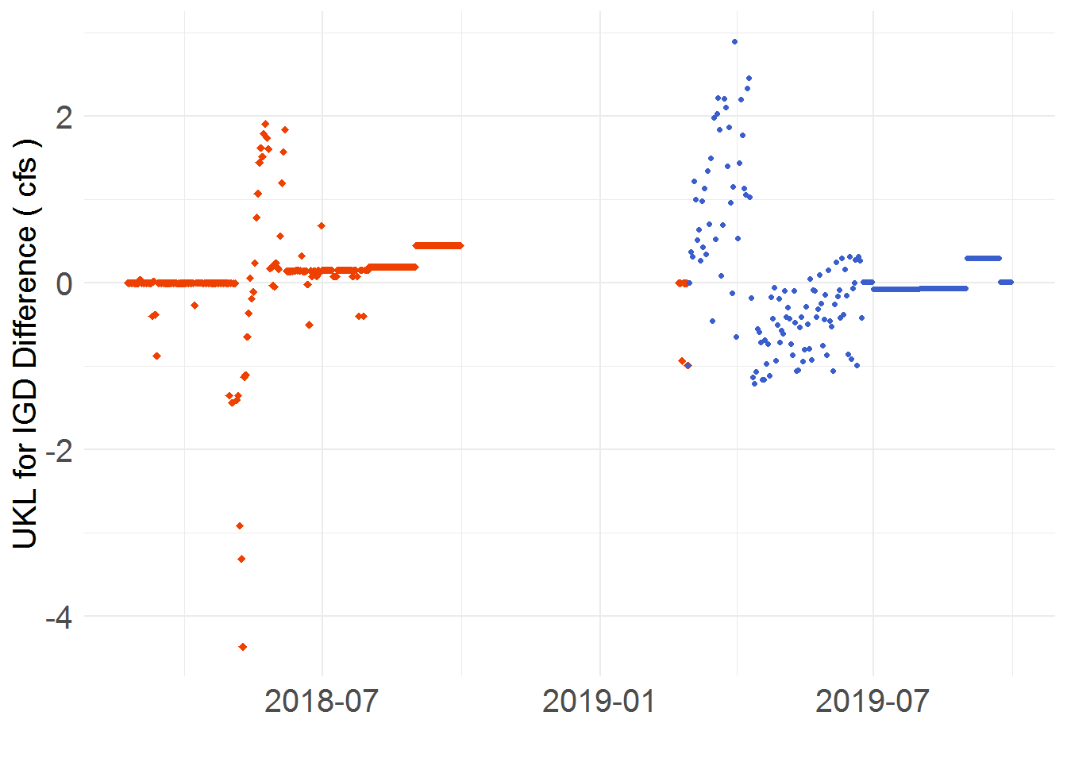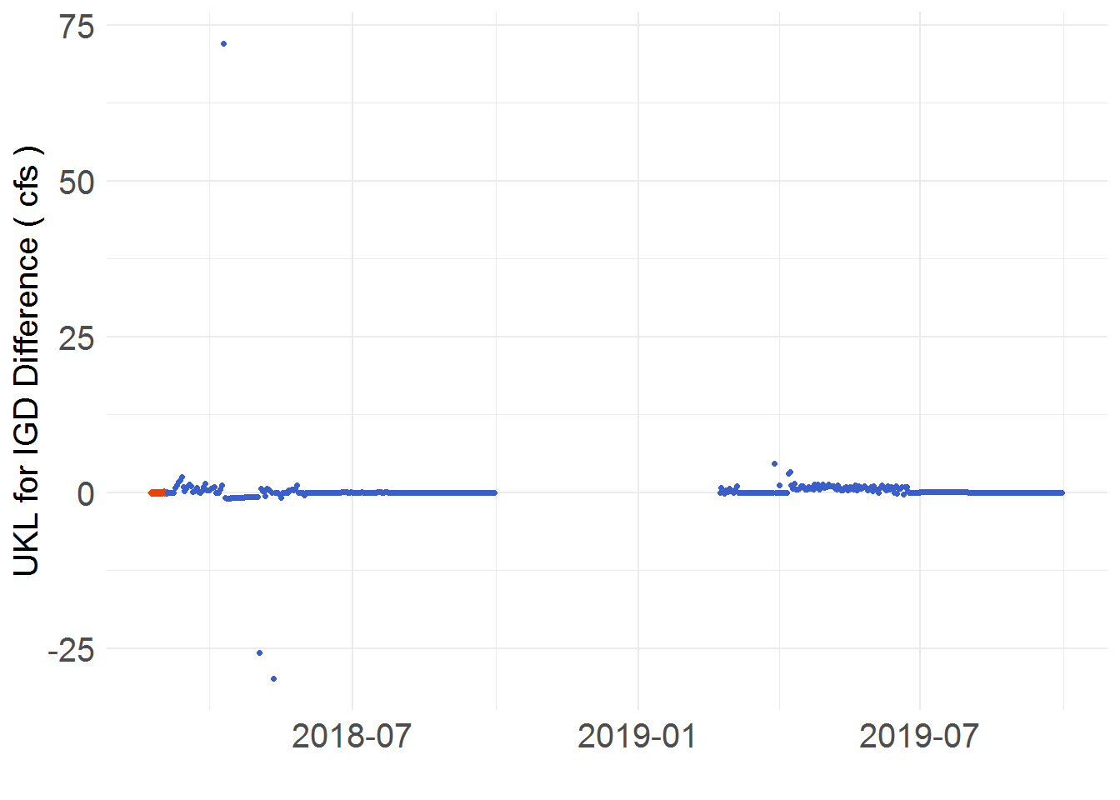

Figure 12. KROM difference for the variable UKL for IGD. The plots are identified by “Operation start dates”. On the left is 03/01/2019 (Plot A) and on the right is 03/05/2018 (Plot B).

Regardless of period (observed or projected), UKL for IGD is expected to always deviate slightly due to the models’ precision differences. The three areas or dependencies the precision differences are traced to are the following: EWA Used, Spring Fill Rate, and Flood Release. As evaluated in an earlier section, flood release differences are a product of differing elevations (LUvI), especially in the predicted period. Since UKL for IGD is dependent on the previous day’s flood release, the effect is lagged one day. Flood release differences tend to cause significant (>10 cfs) UKL for IGD differences due to the magnitude of flows they induce (see Flood Release section), this is shown in the right plot in Figure 10. Here, the difference is ~ 70 cfs, although in other runs it has reached up to ~ 470 cfs as result of flooding.

Spring Fill Rate differences are the other source of significant UKL for IGD differences. To occur, the status of Spring Fill Rate must differ between the models. Thus, one must have it activated and the other deactivated or vice versa. When active, the rate typically falls in the range of 0.85 to 0.95. When inactive, it is set to 1 and thus by multiplying it no change is incurred. This difference of 0.5 to 0.15 is inflated as the Spring Fill Rate is multiplied directly to the release. Thus, a UKL for IGD release of 800 cfs when Spring Fill Rate is inactive becomes anywhere from 680 to 760 cfs when Spring Fill Rate is active. Even when both models’ Spring Fill Rate is active at the same time, differences in elevation lead to Spring Fill Rate differences of up to 0.01. That is enough to alter UKL for IGD releases by up to 4.25 cfs in the March 1, 2019 run as shown in the Plot A of Figure 10.

The most prevalent cause of difference is the EWA Used. While minor in comparison, the EWA Used frequently differs UKL for IGD by 0.1 to 1.5 cfs over the Spring-Summer Period, demonstrated in the left side plot in Figure 10. When no other factors influence UKL for IGD differences, the magnitude of the differences produced by the EWA Used decrease. This happens for two reasons. First, the EWA Used is meant to sum to the EWA (see EWA Used and Remain section). Second, both the EWA Used and UKL for IGD are dependent on each other. EWA Used is dependent on the previous day’s UKL for IGD release and UKL for IGD is dependent on the current day’s EWA Used. Thus, to sum to the EWA volume, the EWA Used adjusts the release from UKL to IGD to meet its target. This causes higher UKL for IGD differences at first and decreases as the models’ EWA Used converges on the EWA.

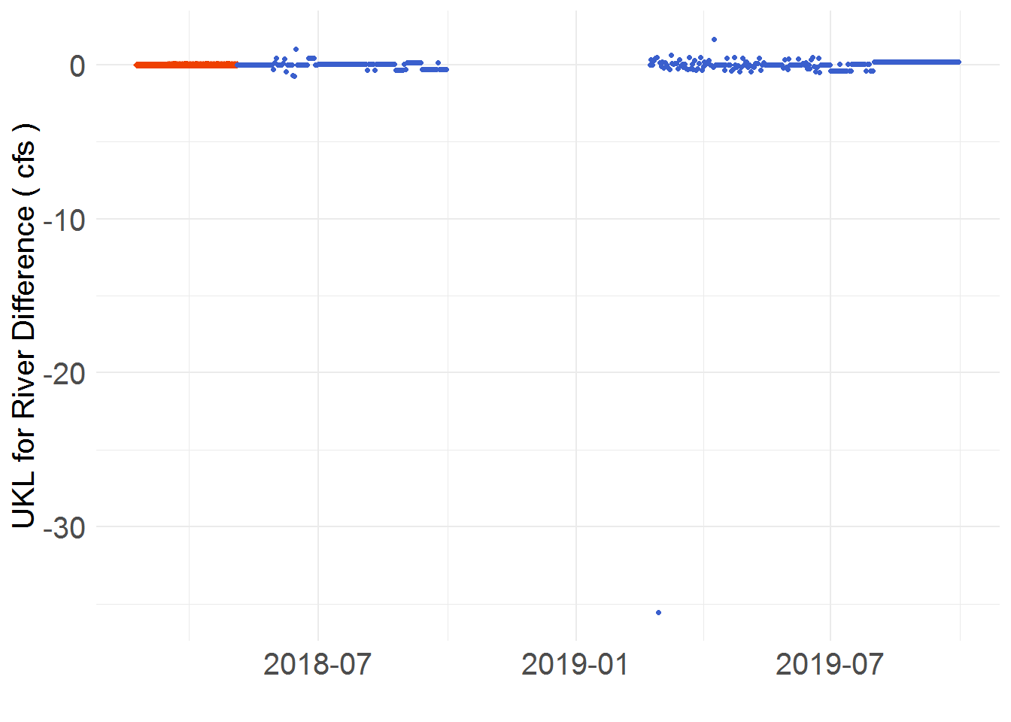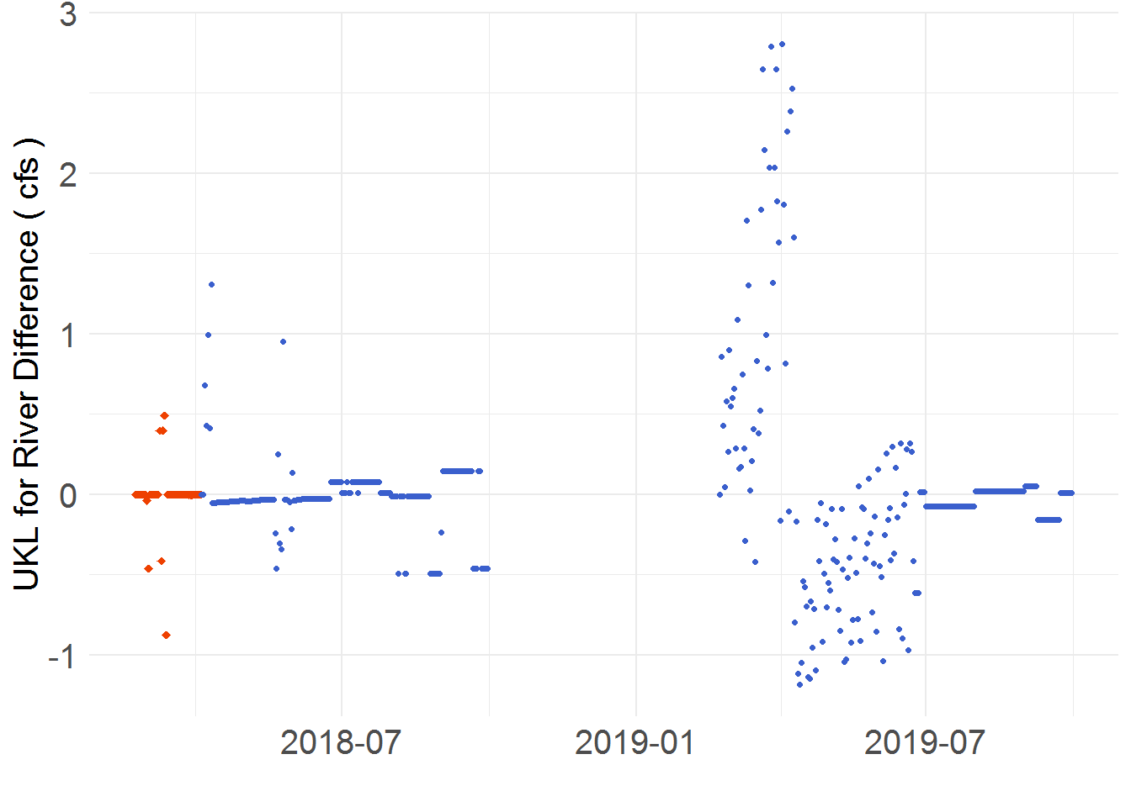

Figure 13. KROM difference for the variable EWA Used. The plots are identified by “Operation start dates”. On the left is 05/05/2017 (Plot A) and on the right is 04/05/2018 (Plot B).

The variable UKL for River is the daily sum of environmental releases from UKL. This includes releases for IGD, minimum flows, ramping, and flooding. The most common release from UKL is for IGD. Thus, differences in UKL for IGD are mirrored by UKL for River. In scenarios where more releases are present, the differences tend to stay under 5 cfs except in the case of flooding. Due to the magnitude of flooding releases and their difference between models, the resultant UKL for River difference is shown to exceed 400 cfs. The 30 cfs difference shown in Plot A of Figure 12 is the product of flood release differences. The differences in Plot B of Figure 12 are a product of UKL for IGD differences.

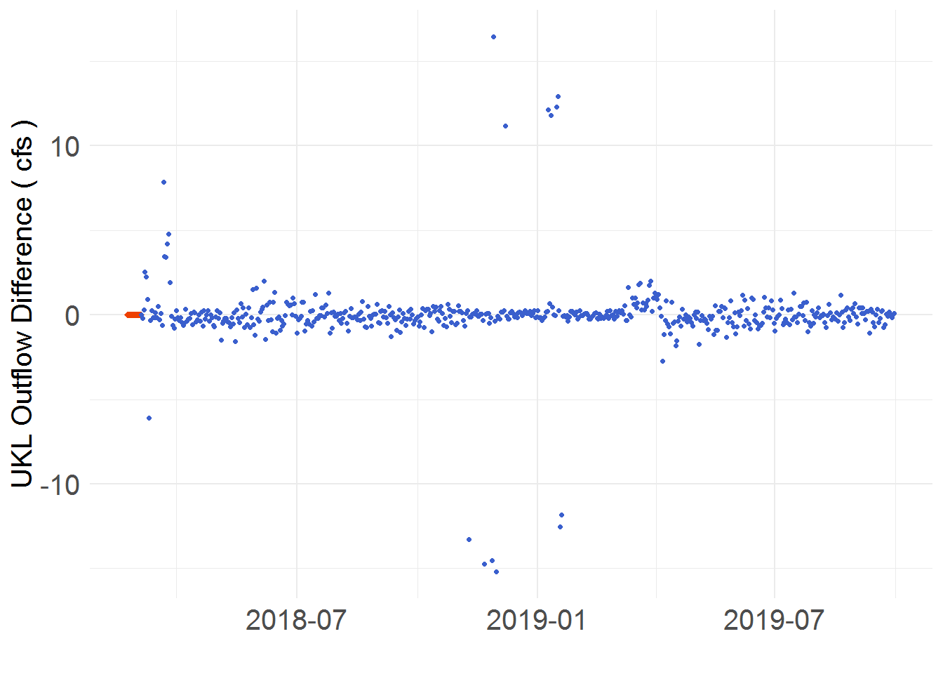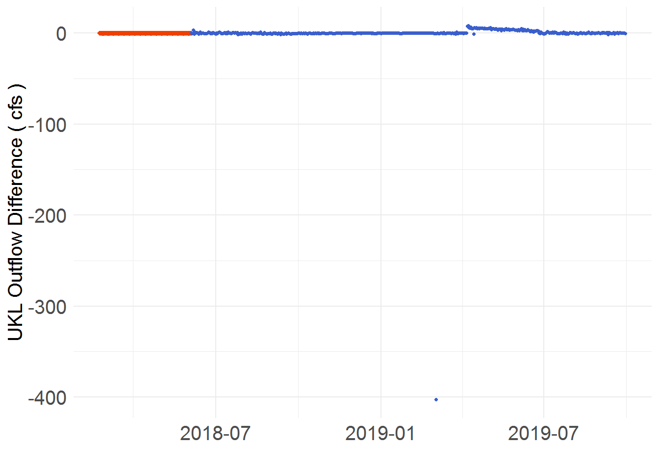

Figure 14. KROM difference for the variable UKL Outflow. The plots are identified by “Operation start dates”. On the left is 03/01/2019 (Plot A) and on the right is 05/05/2018 (Plot B).

During the observed period, no differences occur as the KROM recieves input data that is linked to the IGD Calc. For the predicted period, the UKL Outflow is determined by either UKL for River or Link Fall Winter Target with considerations for agricultural demands, miscellaneous flows, and minimum flow requirements. Since the considerations are predicted with insignificant differences (< 1 cfs), any greater UKL Outflow difference can be traced to variables UKL for River or Link Fall Winter Target. It is simple to identify which as UKL for River is restricted to the Spring-Summer operations and Link Fall Winter Target to the Fall-Winter operations. In Plot A of Figure 13 the differences are marginal (<20 cfs). Differences towards the beginning of the run are a result of Flood Release differences altering the UKL for River. Differences in the middle of the run are a product of the UKL Pool Elevation (LUvI) differences skewing the Link Fall Winter Target. In Plot B of Figure 13 a large, negative difference (~400 cfs) followed by constant, positive difference ( ~ 1-5 cfs) is demonstrated. The large, negative difference is caused by the KROM possesing a significantly lower flood release than the IGD Calc. As a secondary effect of the reduced flood release, the EWA Used volume also decreases. Thus, UKL for IGD and sequentially UKL Outflow is increased to utilize the additional volume left in the EWA. This produces the constant, positive difference shown throughout the rest of the run.

## Surface and Deep Flushing

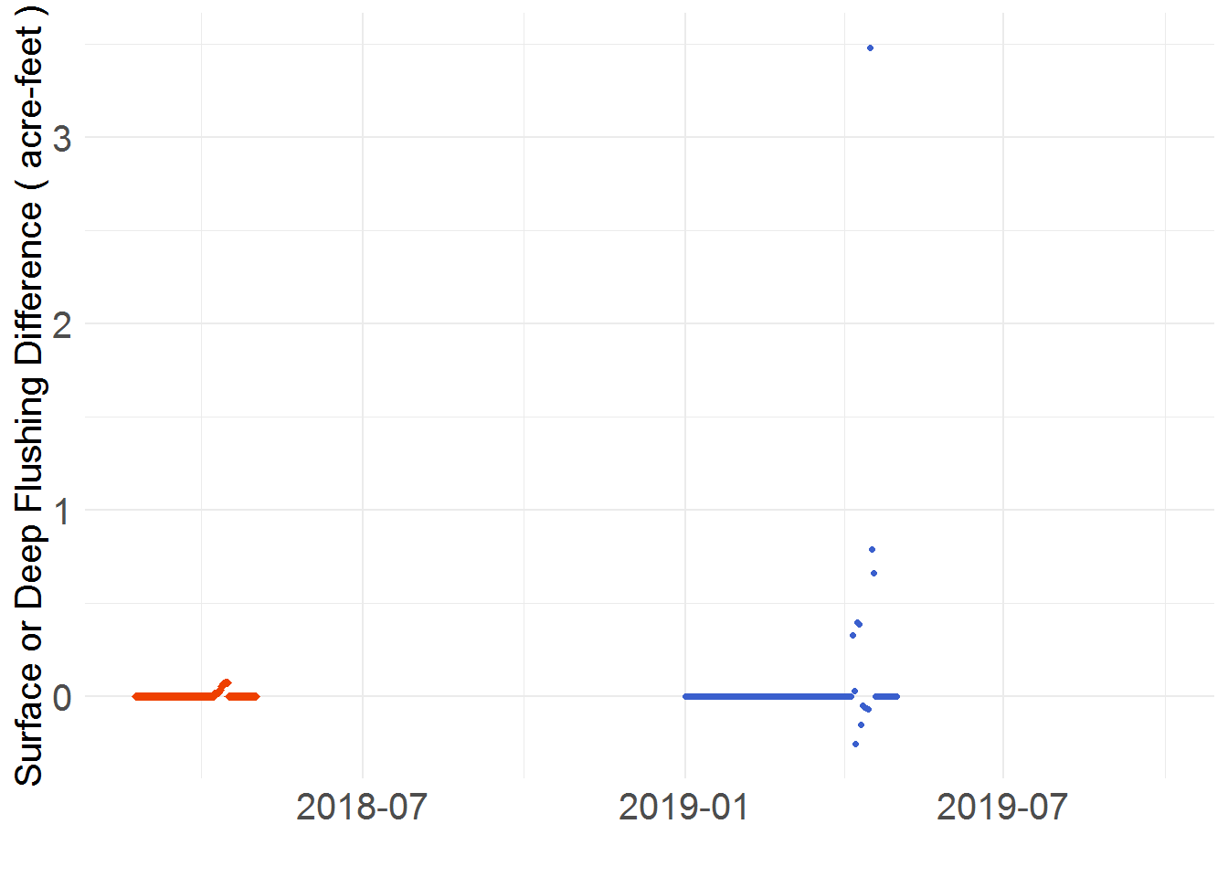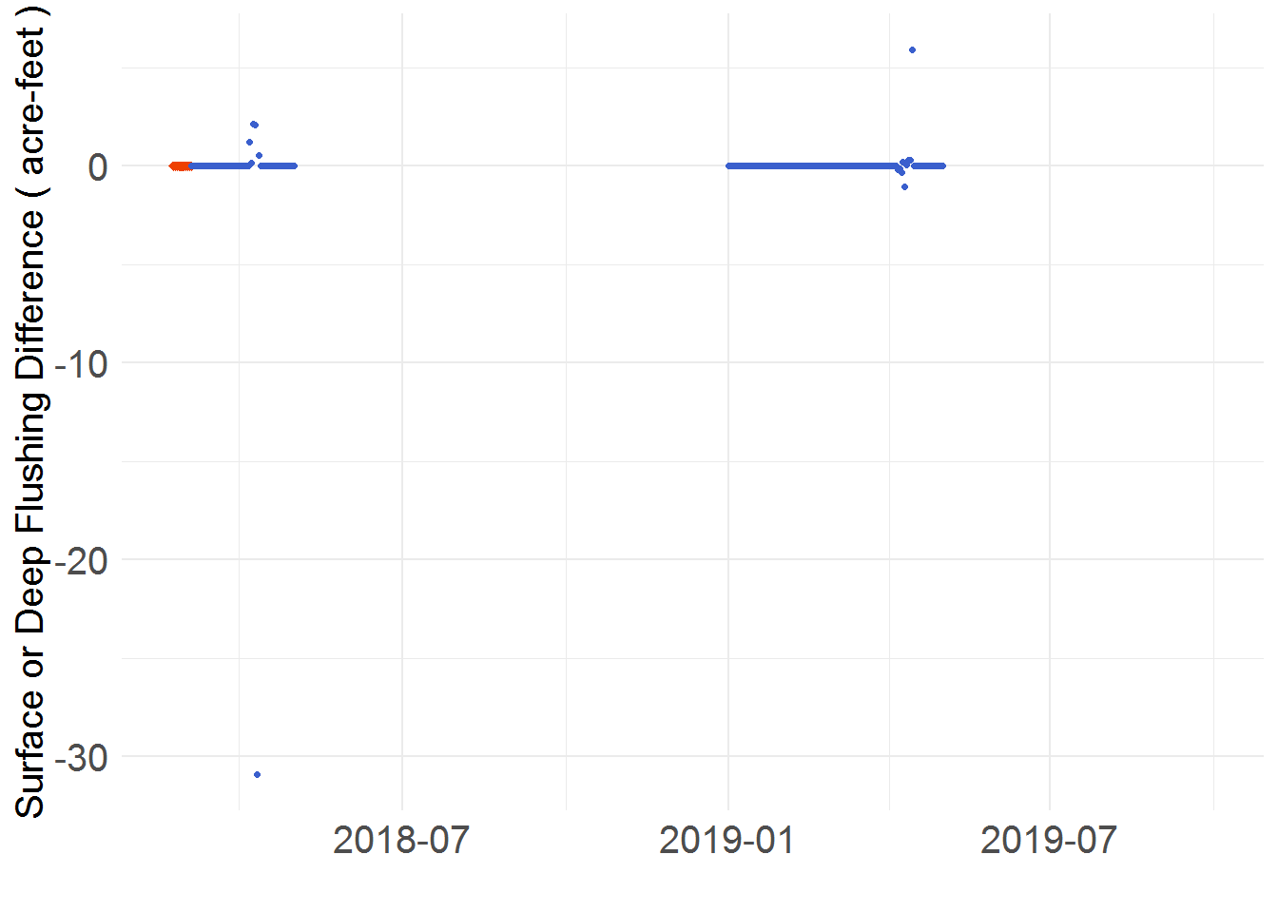

Figure 15. KROM difference for the variable Surface and Deep Flushing. The plots are identified by “Operation start dates”. On the left is 10/01/2017 (Plot A) and on the right is 03/05/2018 (Plot B).

To assign Surface and Deep Flushing, the difference between a set constant and the estimated release at IGD is taken when the conditional statements of the functions have been met. Because the recorded release at IGD is not used, the models are able to differ in the observed and predicted periods. Analyzing and tracing the sources of differences through the function’s dependencies, the primary variables causing differences are identified as both UKL for IGD and Flood Release. This explains why differences in the observed period tend to be smaller as both variables differ little (< 10 cfs) through that timespan. However, once in the predicted period, the variable’s differences increase in magnitude. This can cause Surface and Deep Flushing to differ to over 30 cfs when the conditional statements are met. The conditional statements are primarily dependent on whether the timestep falls within the Surface and Deep Flushing release period. Since this is a short period, the conditions are only met and releases for approximately 10 to 15 days out of a year. With such a short window of activity, most differences won’t affect this value unless their timing is synchronized. In Plot A of Figure 14, the flood release difference occurs before Surface and Deep Flushing is set. Thus, all differences seen keep below 3 acre-feet. In Plot B of Figure 14, the flood release difference occurs on the same timestep Surface and Deep Flushing is set. This causes a difference of ~ 30 cfs in 2018 and ~ 10 cfs in 2019.

# Discussion

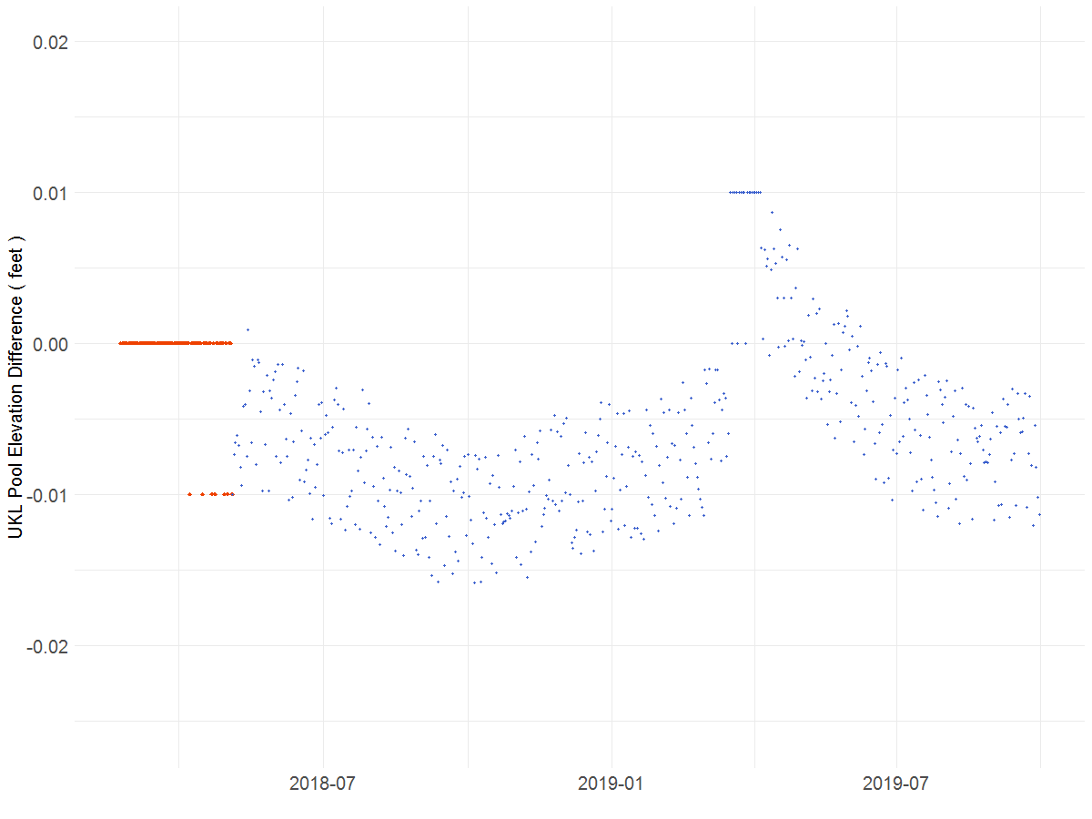

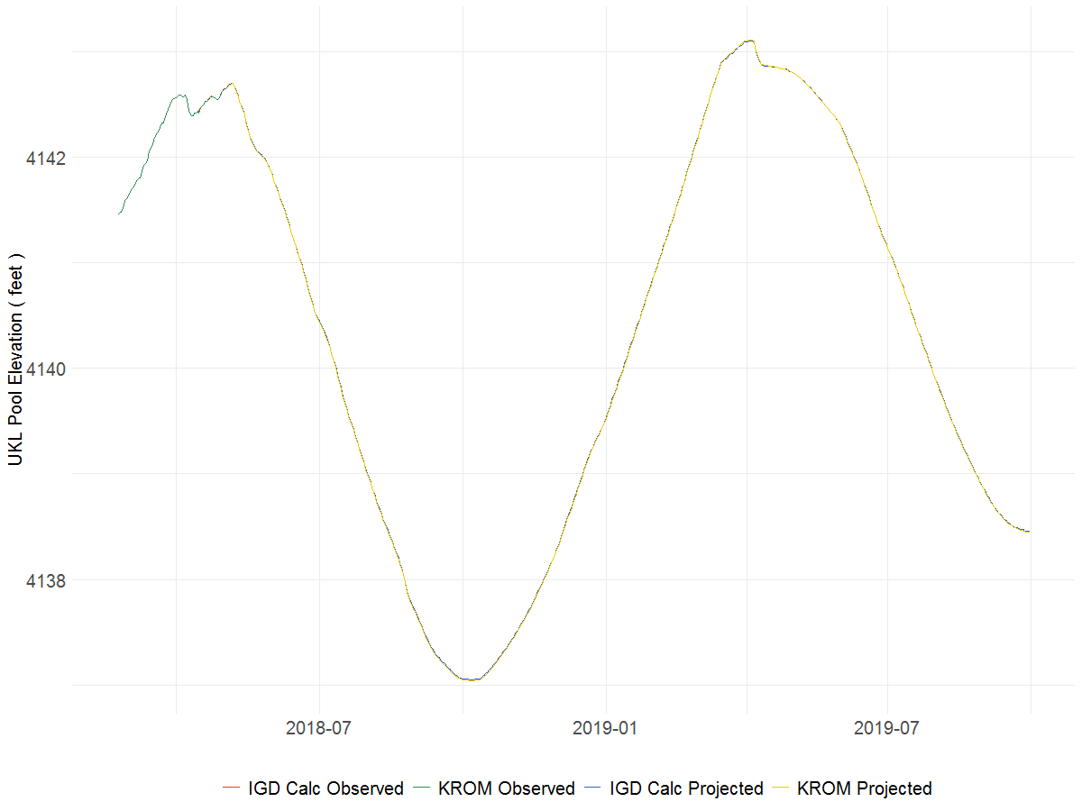

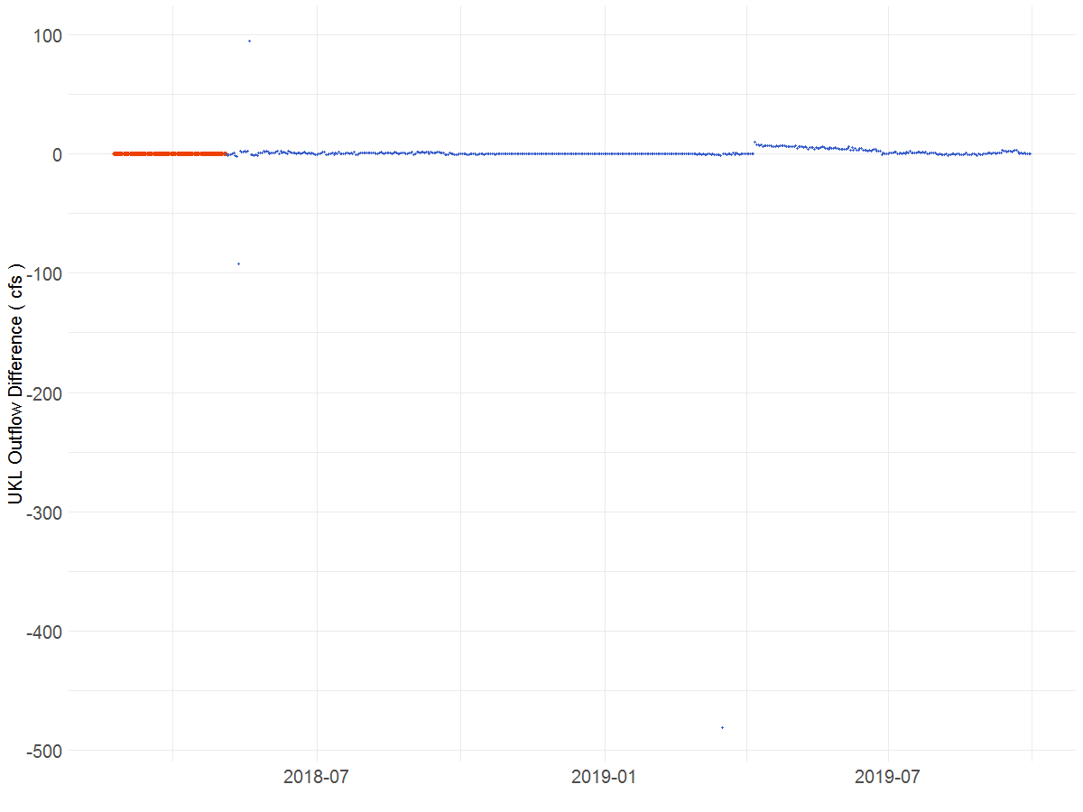

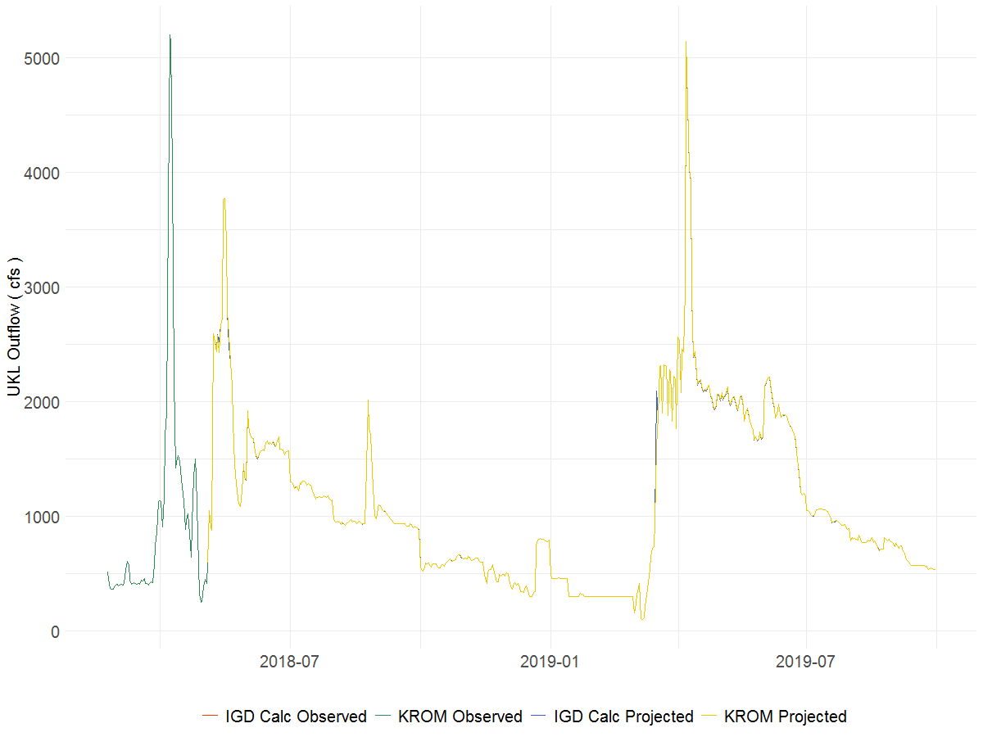

Figure 16. Comparison of variable differences to their relative magnitude. The bottom plots show a comparison of the model’s variables whereas the top plot shows the variables’ difference. The plots’ “Operation Start Date” is 05/05/2018. From top to bottom, Plots A&B are for UKL Pool Elevation and Plots C&D are for UKL Outflow.

The purpose of this report is to test the KROM’s ability to run the basin’s operational policy. Throughout the analysis of key variables and the methodologies that calculate/assign them, some reoccurring inconsistencies between the KROM and IGD Calc are discovered. While these inconsistencies produce variable differences throughout the model runs, the relative magnitude of differences to the general quantity is small. Therefore, the KROM is deemed capable of running the basin’s operational policy with differences between the models’ calculations deemed unavoidable due to fundamental method inconsistencies.

The primary inconsistencies between the models concerns converting daily average flows to volumes and setting the elevation at UKL. Since the inconsistencies cause reoccurring differences for many variable calculations, they are denoted. The conversion inconsistency is denoted Model Conversion Difference or MCD. It occurs due to the precision at which daily average flows are converted to volumes or vice versa. The IGD Calc is precise to the 4th decimal whereas the KROM is to the 10th decimal. While a value difference starting on the 5th decimal seems minor, the difference becomes exacerbated when converting flows reaching into the 1000’s of cfs. The best demonstration of a variable difference caused solely by this inconsistency is the A Canal Diversion. A demonstration of MCD’s greater influence is the EWA Used. This is a variable which requires large flows (500 to 2000 cfs) to be converted to a volume. If off, the difference propagates through to dependent variables (directly or through another variable). A few of which are the following: UKL for IGD, UKL for River, UKL Outflow, EWA Remain, Surface and Deep Flushing.

The elevation assignment inconsistency is denoted Look Up versus Interpolation or LUvI. This is characterized as a function inconsistency. The IGD Calc has an Elevation Volume Table which is identical to the one in the KROM. To assign a pool elevation, it references the calculated volume or elevation by using a Look Up function. This Look Up function is precise to the 2nd decimal and rounds down. In the KROM, the volume or elevation is also referenced to the table. Instead, it uses an Interpolation function to set a value which is proportionally between the nearest volumes/elevations. The best demonstration of this inconsistency is shown on the plots of UKL Pool Elevation during the predicted period. As for a greater influence, the Flood Release is applicable. The models’ Flood Release typically differs in the first two days as the starting elevations are inequivalent. As a result, over or under releases occur before the models can reach an identical elevation set by the flood control policy. Once off, the release difference propagates through to dependent variables. A few of which are the following: EWA Used and Remain, UKL for IGD, UKL for River, UKL Outflow, Surface and Deep Flushing.

To demonstrate that the inconsistencies do not hinder the KROM’s ability to run the basin’s operation policy, Figures 15 is presented. In Plot A and B of Figure 15, the differences in UKL Pool Elevation are shown. Plot B demonstrates the scattered nature of this assignment. Plot A demonstrates the limited effect it has on KROM predicting elevation. To assess the differences, the significance is calculated. Thus, the largest difference of 0.02 feet has a significance of 0.3%. In Plot C and D of Figure 15, the differences in UKL Outflow are shown. Plot D demonstrates the large under releases (~ 100 to 500 cfs). Plot C demonstrates KROM’s overall accuracy. The difference of ~ 485 cfs equates to a significance of 9.33%. The remaining differences afterwards are much smaller. At most they are 15 cfs, which has a significance of 0.29%.

Based on the significance of the differences and their inability to hinder application of basin operational policy, the testing concludes that the KROM sufficiently matches the IGD Calc’s capabilities. No efforts are needed to address the inconsistencies as they are inherent to the models and the resultant effect is negligible. Phase 2, Task 4 is concluded and efforts towards the next task can begin.

# Appendix